1. **S3 Replication Overview:**

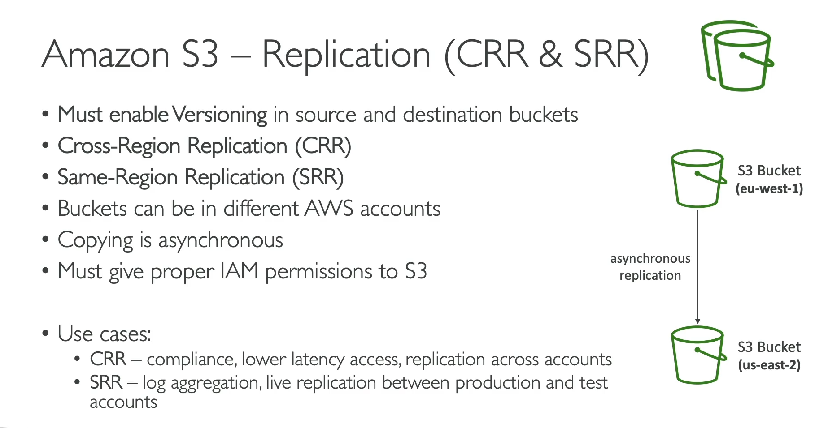

Amazon S3 Replication automatically copies objects between S3 buckets. There are two types: Cross-Region Replication (CRR) and Same-Region Replication (SRR).

**How It Works**

* **Asynchronous Process**: Replication happens automatically and asynchronously in the background. When an object is uploaded to the source bucket, a copy is made in the destination bucket.
* **Versioning is Required**: Both the **source** and **destination** buckets must have **Versioning enabled** for replication to work.
* **IAM Permissions**: Proper IAM permissions must be granted to the S3 service so that it can read objects from the source bucket and write them to the destination bucket.
* **Cross-Account Replication**: The source and destination buckets can be in the same AWS account or in two different accounts.

**Types of S3 Replication**

**Cross-Region Replication (CRR) 🌍**

* Copies objects between S3 buckets in **different AWS regions**.
* **Use Cases:**
  + **Compliance and Disaster Recovery**: Replicates data to a geographically separate region for business continuity and regulatory compliance.
  + **Lower Latency**: Reduces latency for users by providing access to data from a closer region.
  + **Data Sovereignty**: Keeps a copy of data in a specific country or region to meet data residency requirements.

**Same-Region Replication (SRR) 🏠**

* Copies objects between S3 buckets in the **same AWS region**.
* **Use Cases:**
  + **Log Aggregation**: Consolidates logs from multiple buckets into a single, centralized bucket for easier processing and analysis.
  + **Production to Test Environment**: Creates a live replica of production data in a separate test account for development and testing purposes.
  + **Data Security**: Replicates data to a separate bucket with different ownership to prevent accidental deletion.

1. **S3 Replication Hands On:**

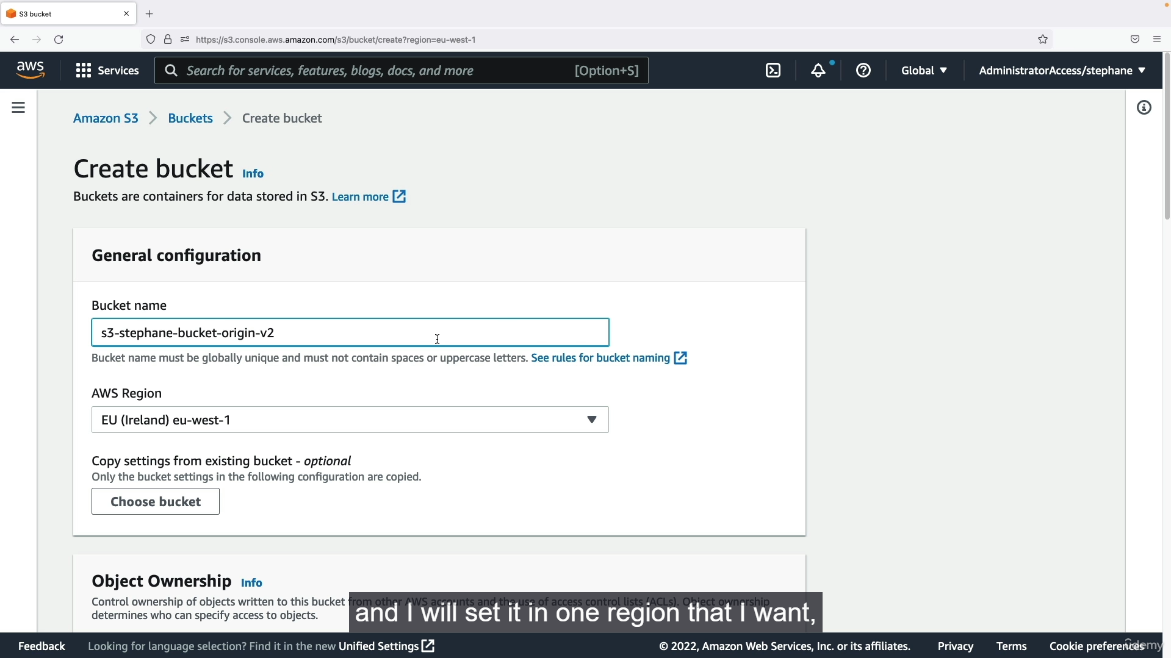

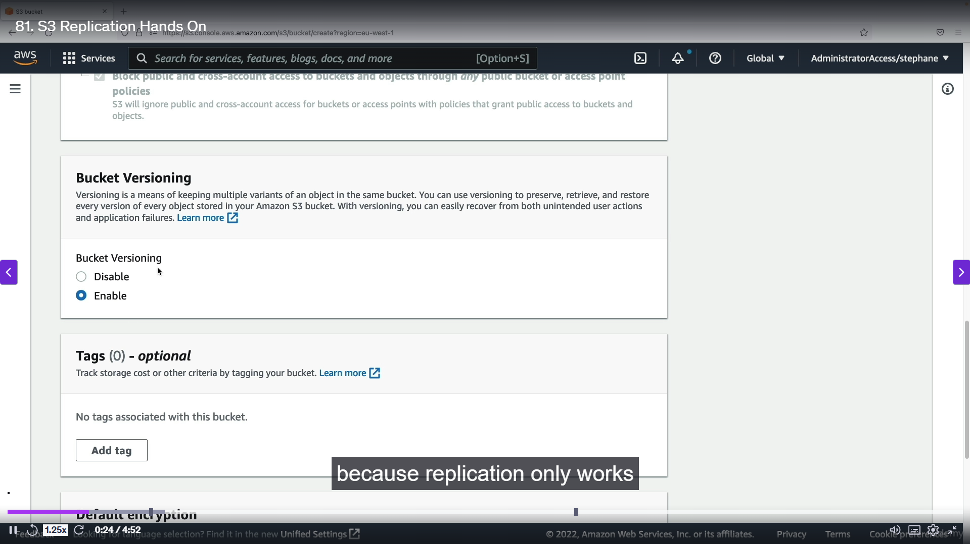

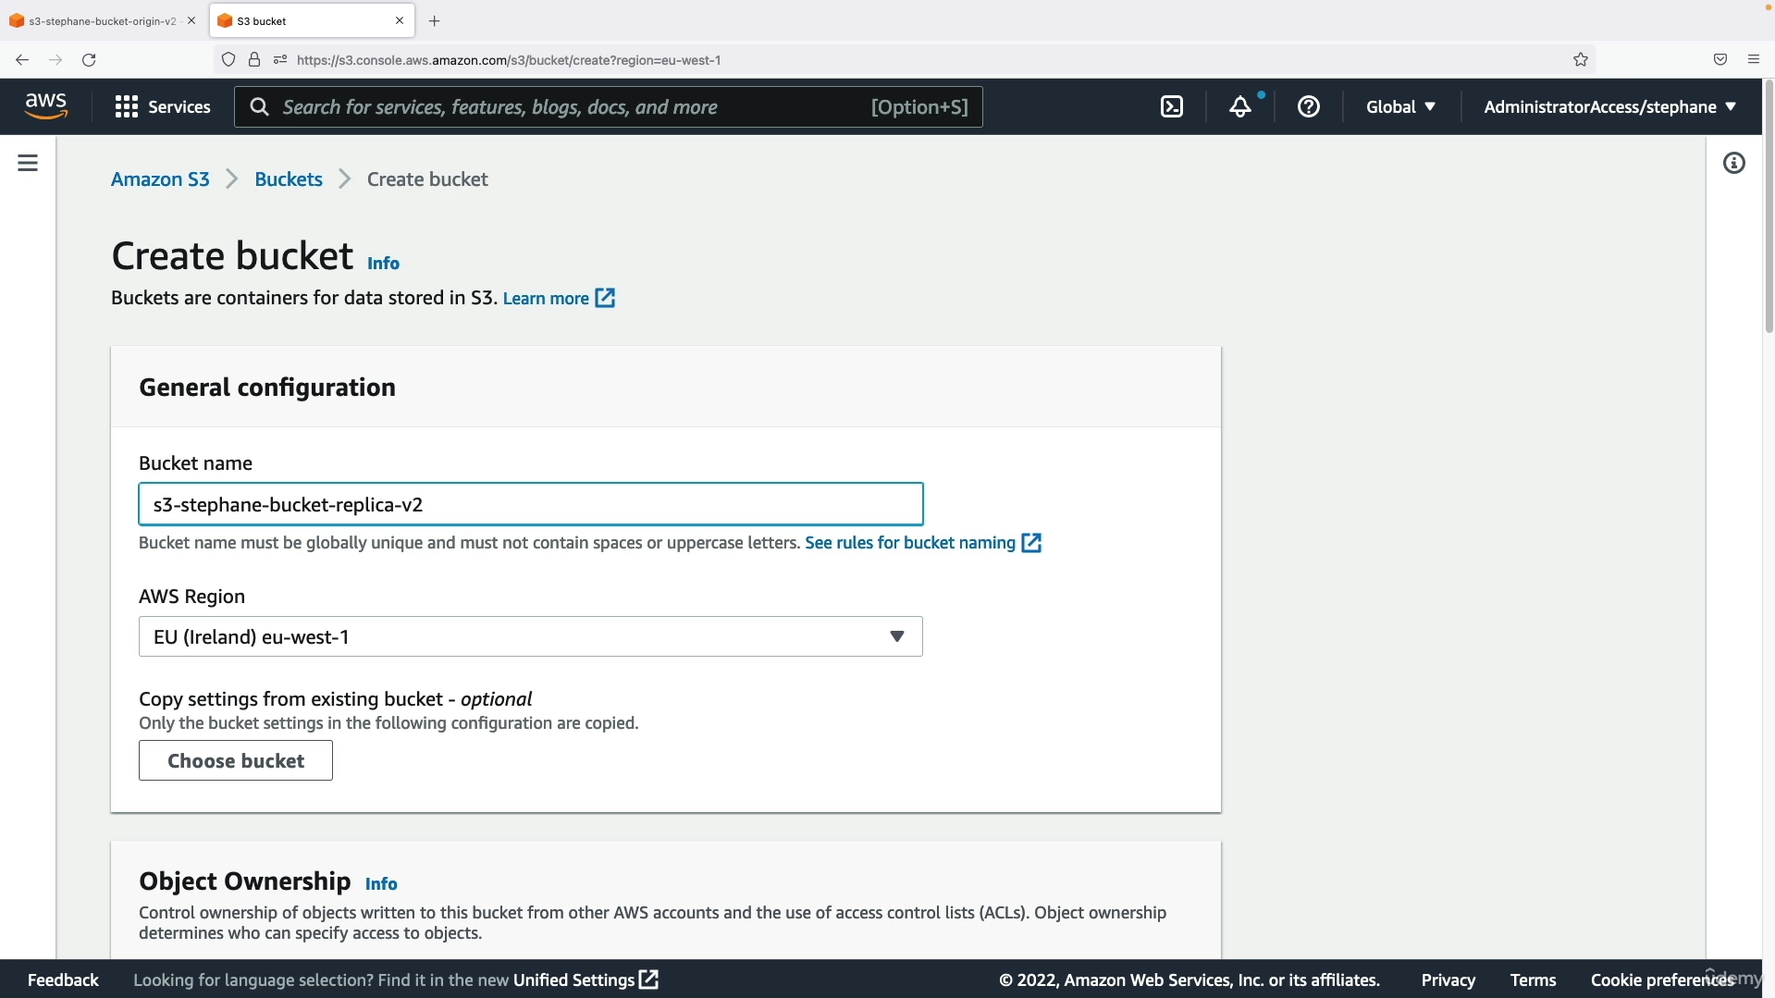

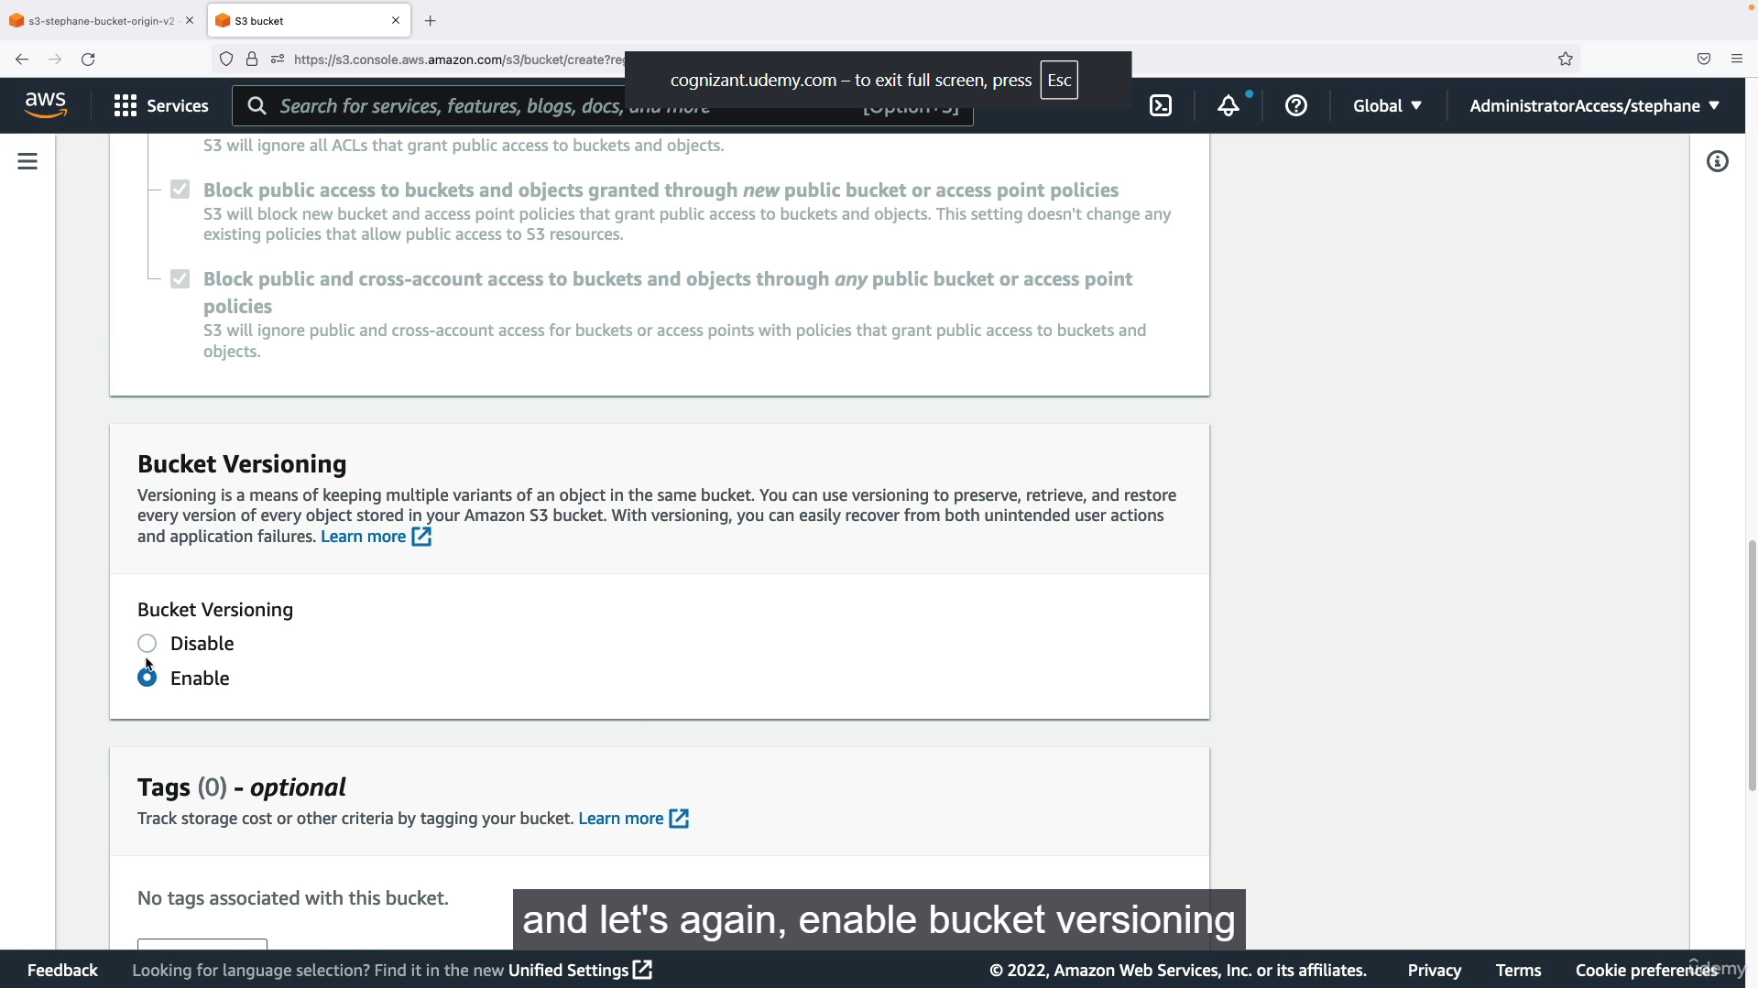

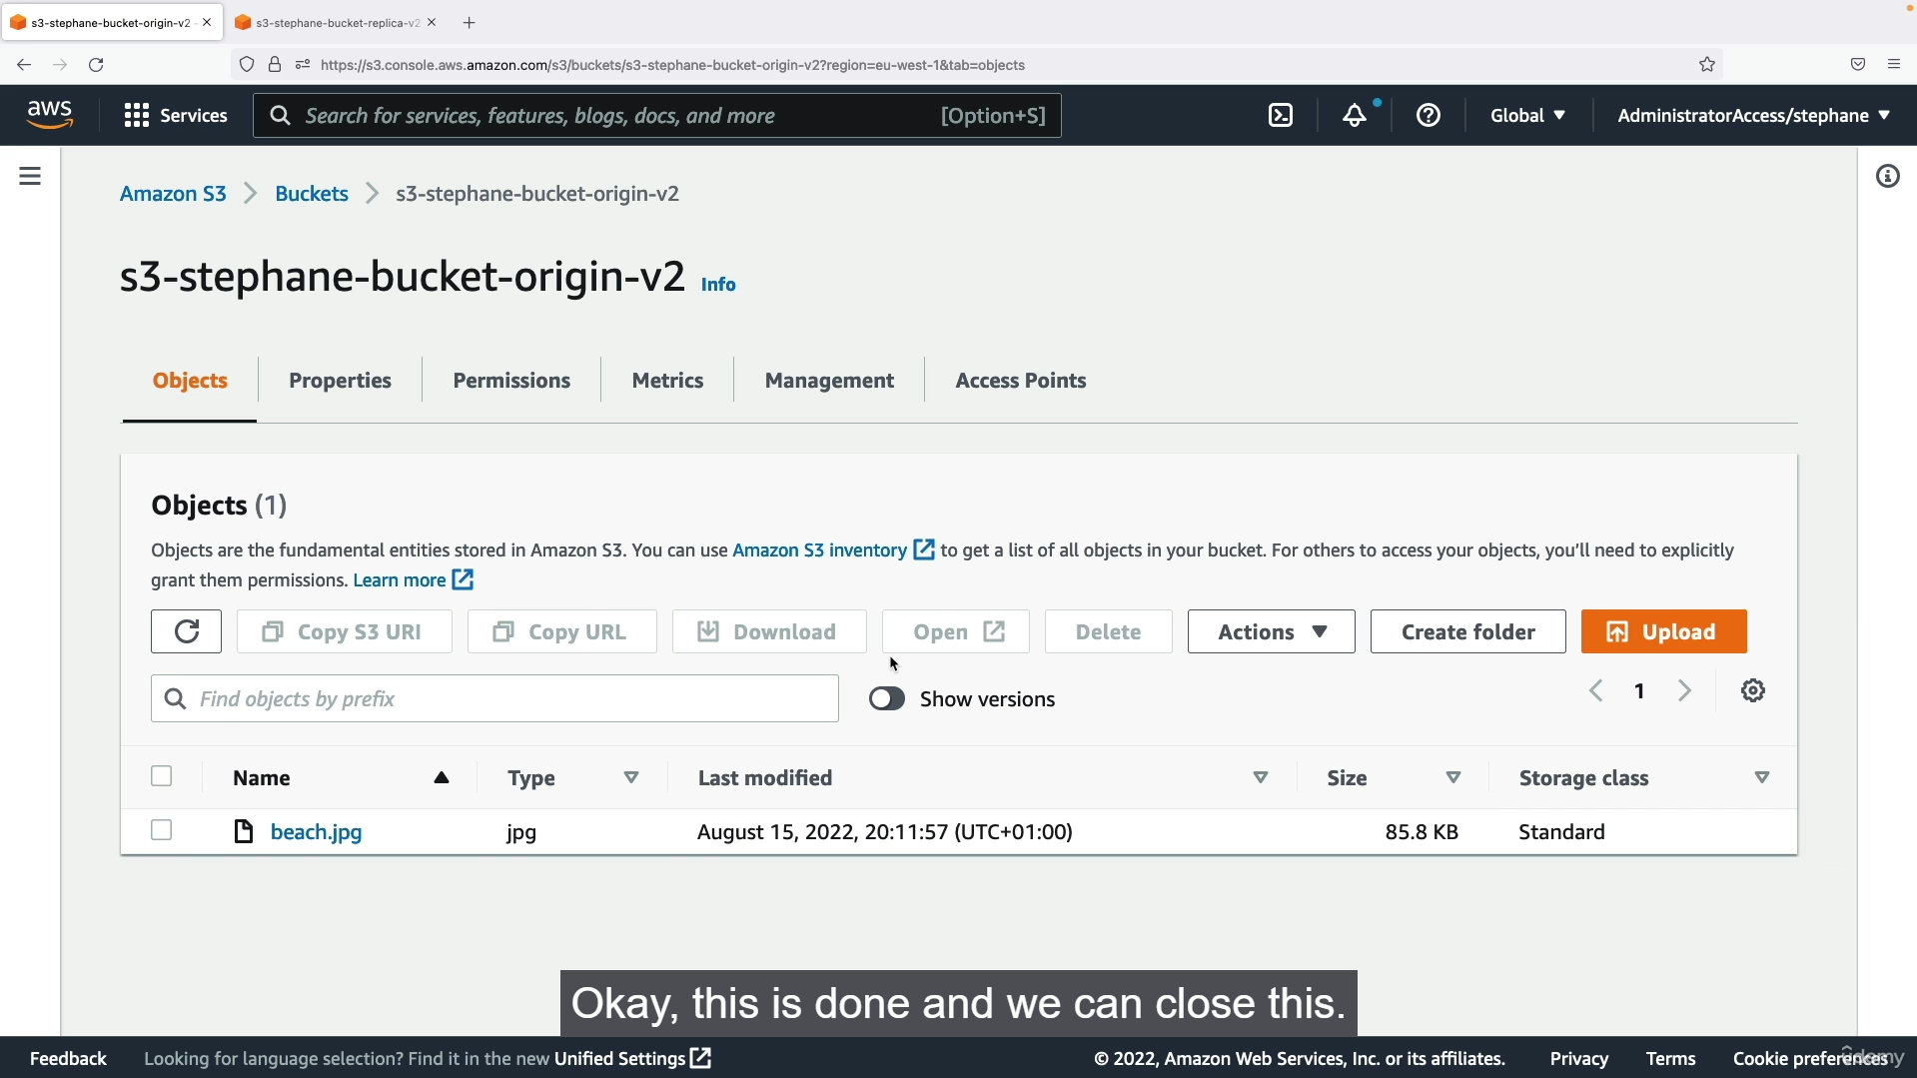

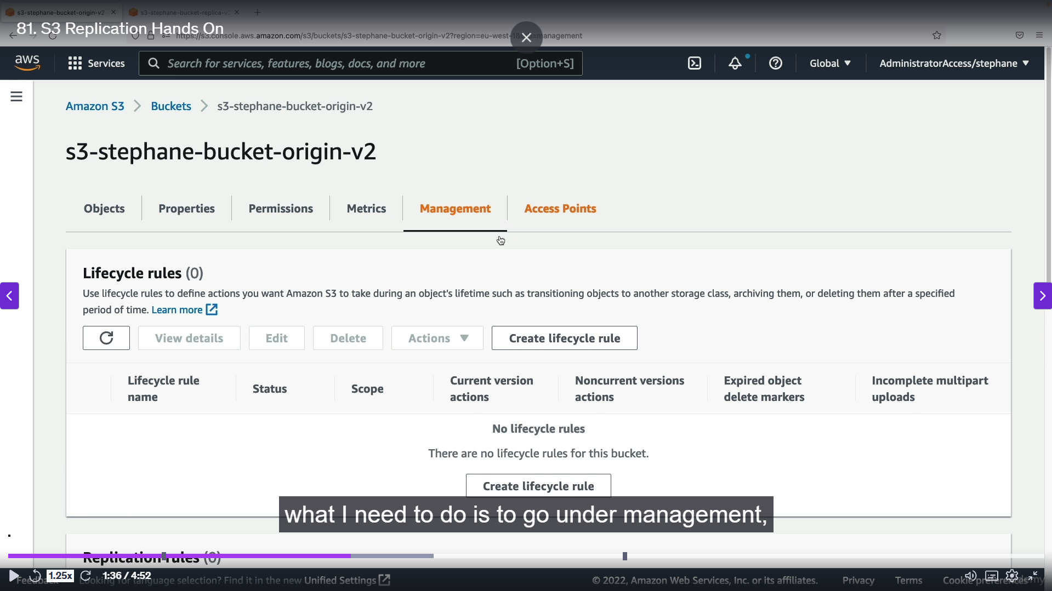

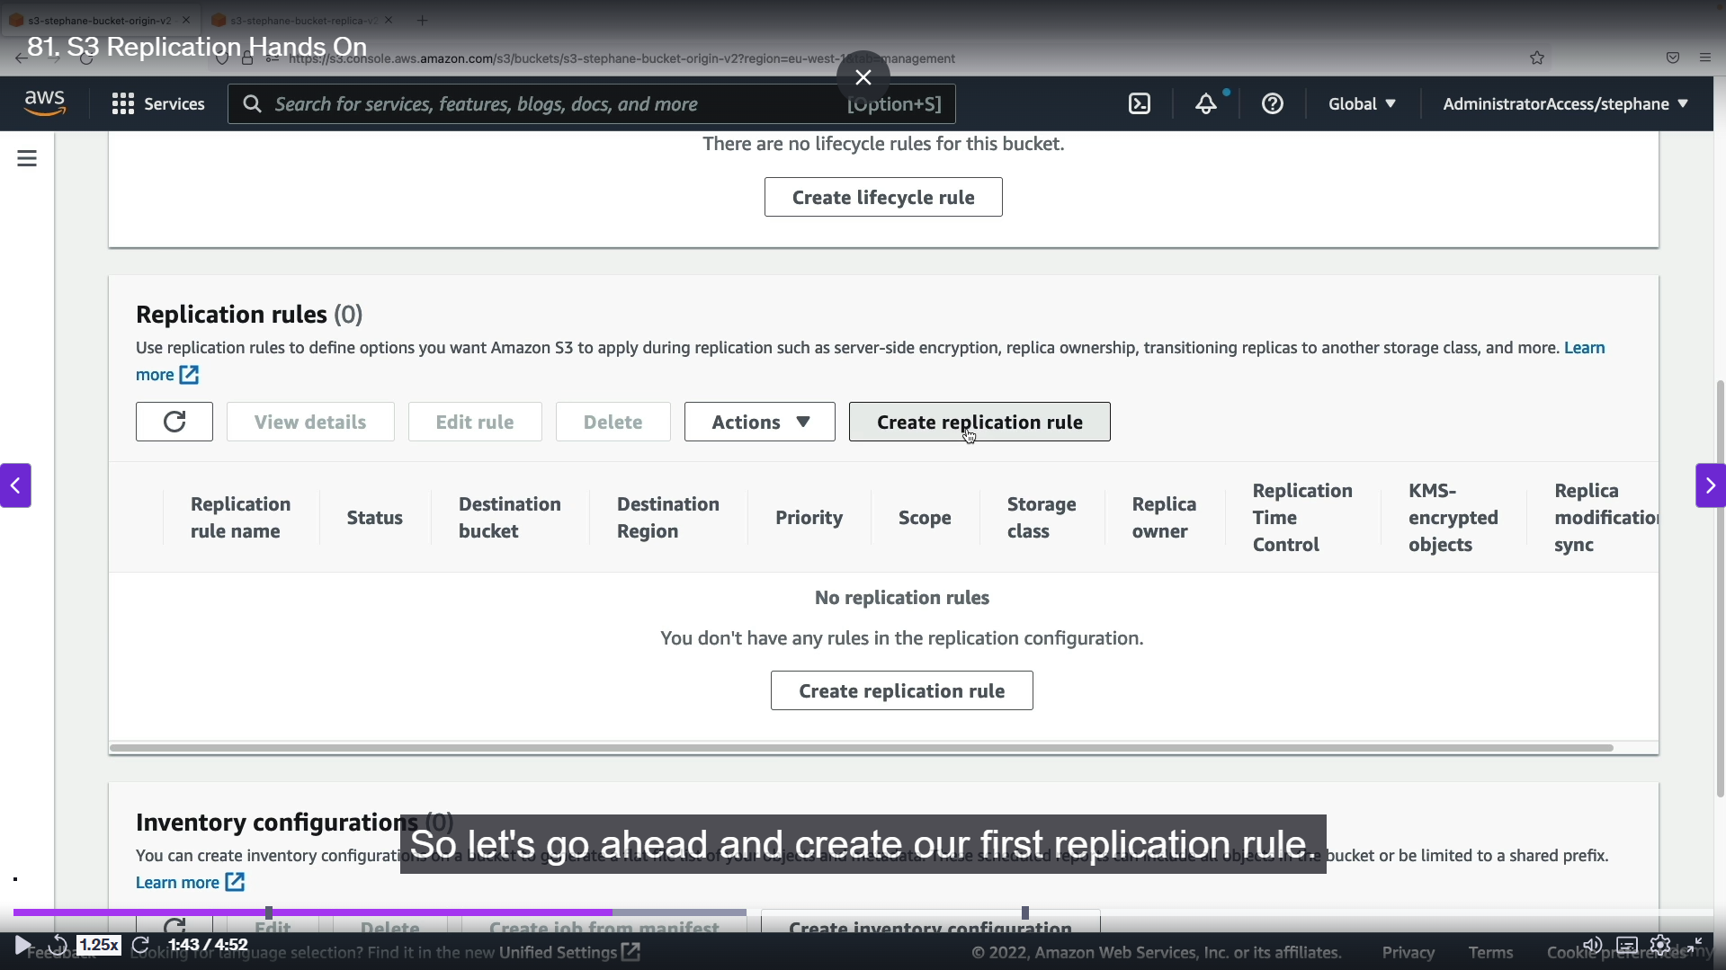

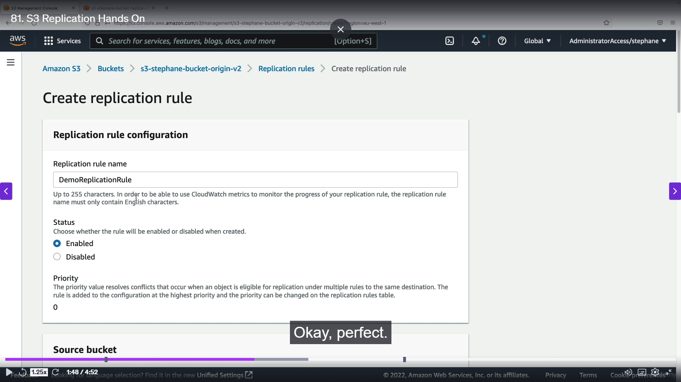

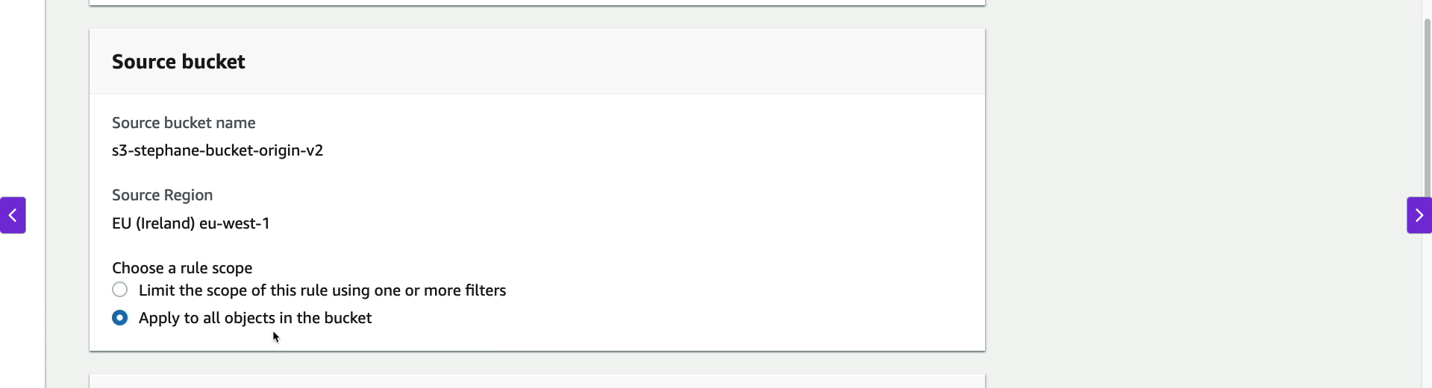

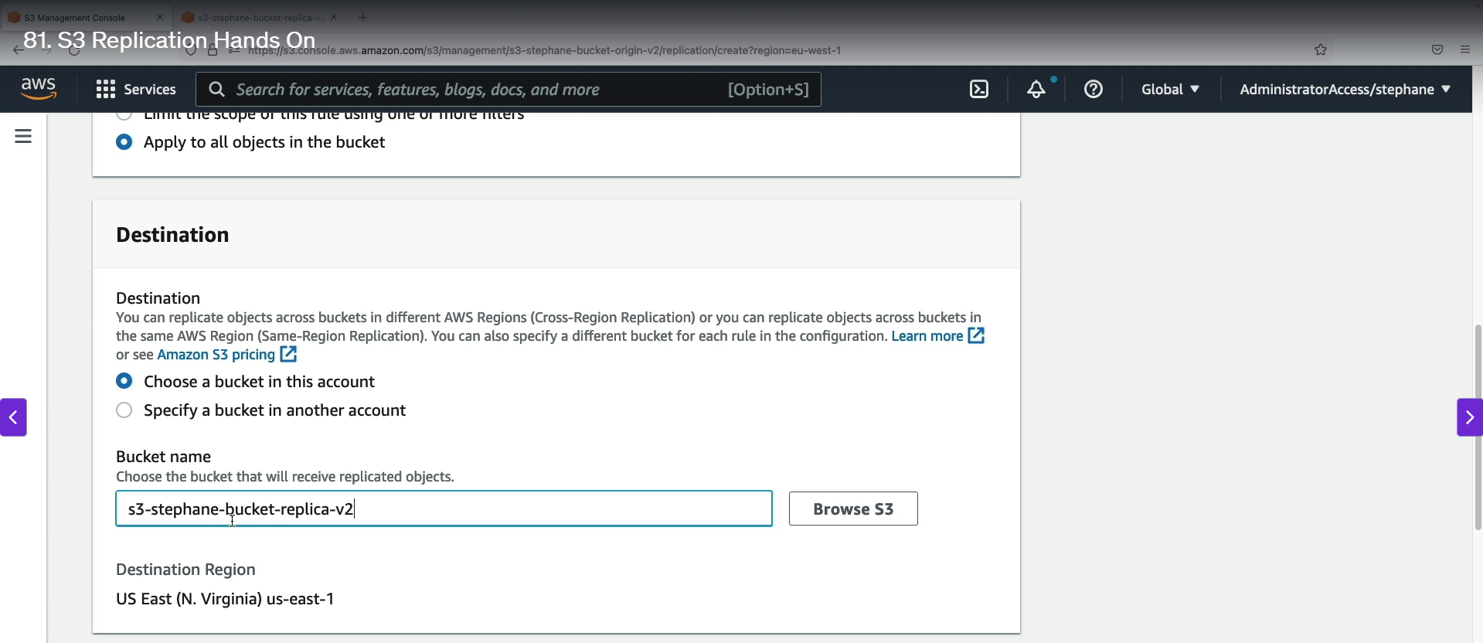

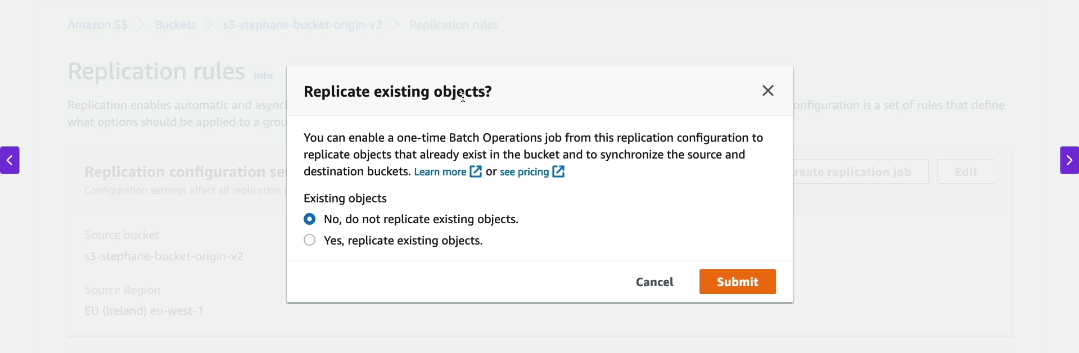

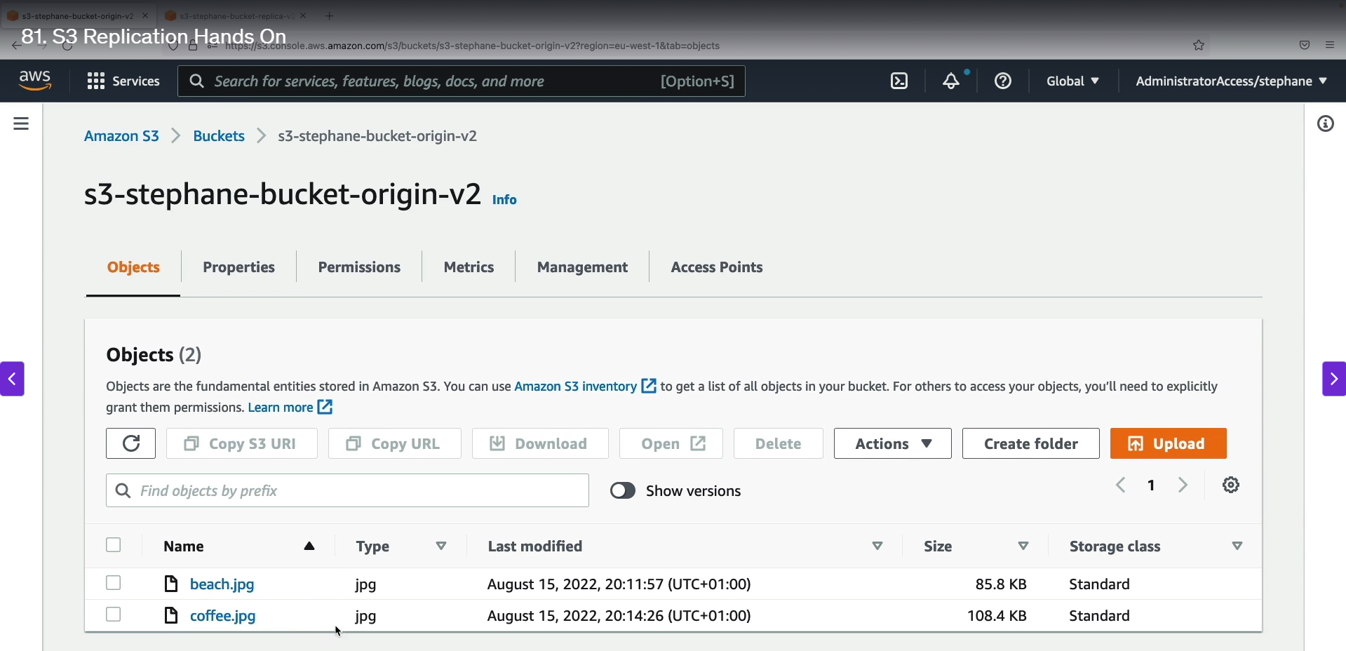

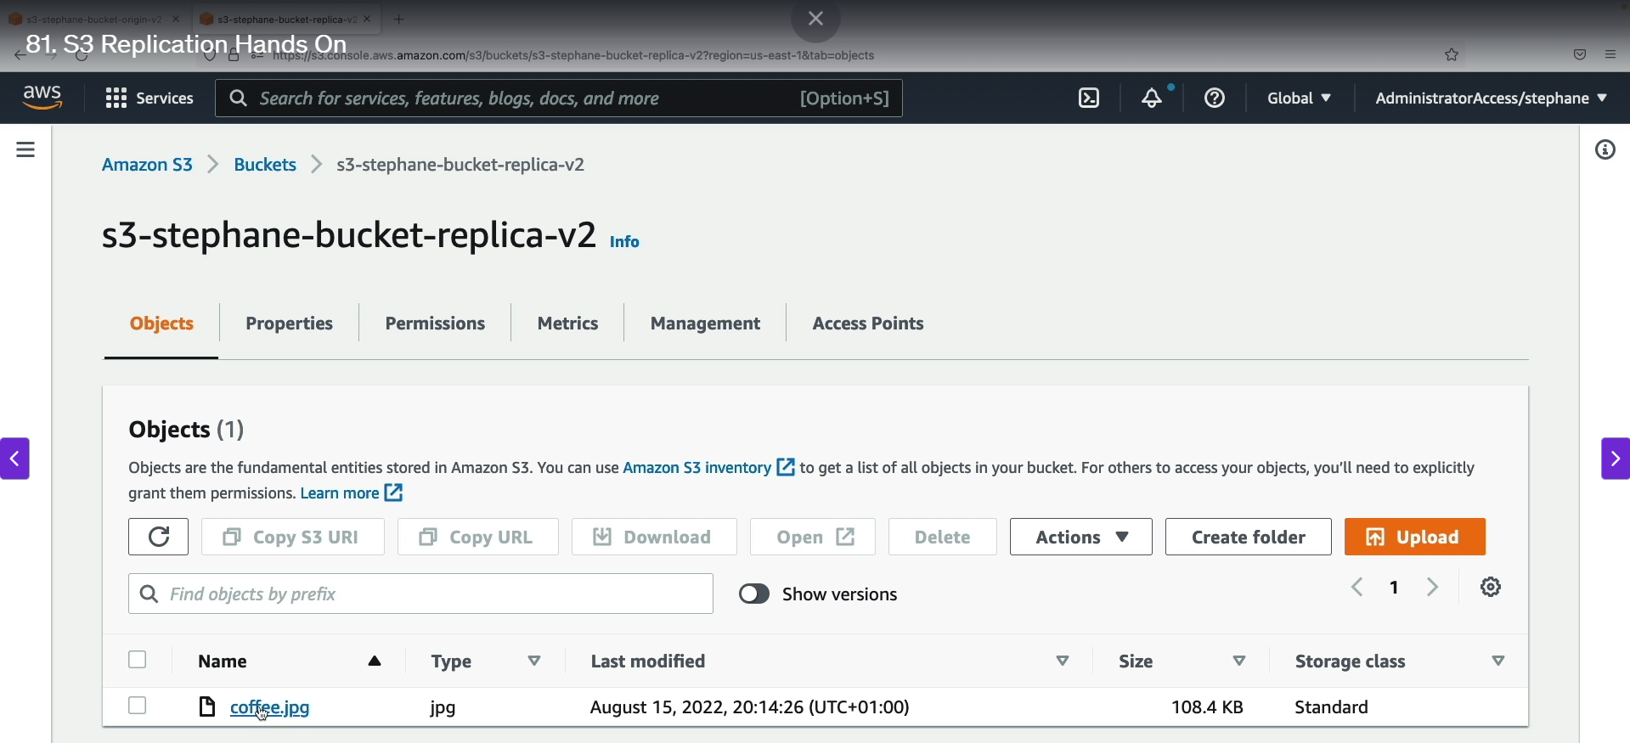

Setting up Amazon S3 replication is a multi-step process that involves creating two buckets, enabling versioning on both, and then configuring a replication rule. This process allows you to automatically and asynchronously copy new objects from a source bucket to a destination bucket in the same or a different region.

**Step-by-Step Guide to S3 Replication**

**Part 1: Bucket Setup and Prerequisites**

1. **Create Two Buckets:** Create two separate S3 buckets. One will be the **origin bucket** (the source of the files) and the other will be the **replica bucket** (the destination). You can place these buckets in the same region or in different regions for cross-region replication (CRR). For this example, let's say the origin is in EU (Ireland) and the replica is in US East (N. Virginia).
2. **Enable Versioning:** **Versioning must be enabled** on both the origin and replica buckets. This is a critical prerequisite for S3 replication to function. Navigate to each bucket's "Properties" tab, find the "Bucket Versioning" section, click "Edit," and enable it.

**Part 2: Configuring the Replication Rule**

1. **Navigate to Replication Rules:** In the S3 console, select your **origin bucket**. Go to the **"Management"** tab and scroll down to the "Replication rules" section. Click "Create replication rule."
2. **Define the Rule Scope:** Give the rule a name (e.g., demo-replication-rule). For the "Rule scope," choose to apply the rule to **all objects** in the bucket.
3. **Specify the Destination:** Under the "Destination" section, choose to replicate objects to a bucket in the "This account" option. Enter the name of your replica bucket. The destination region will be automatically identified.
4. **Create an IAM Role:** Replication requires an **IAM role** that grants S3 the permissions to read objects from the source bucket and write them to the destination bucket. Select the option to "Create new role." AWS will automatically create a role with the necessary permissions.
5. **Replicate Existing Objects (Optional):** You will be asked if you want to replicate existing objects. By default, S3 replication only applies to new objects uploaded after the rule is created. If you need to replicate older files, you would need to use a separate **S3 Batch Operation** job. In this scenario, we will select "No, do not replicate existing objects."
6. **Save the Rule:** Review your settings and click "Save." Your replication rule is now active.

**Part 3: Testing Replication**

1. **Upload a New Object:** With the replication rule in place, upload a new file (e.g., coffee.jpeg) to the **origin bucket**.
2. **Verify Replication:** Wait a few moments for the replication to occur. Then, go to your **replica bucket** and refresh the page. You should see the coffee.jpeg file appear. The file's version ID in the replica bucket will be the **exact same** as its version ID in the origin bucket, confirming that the replication was successful and identical.
3. **Replicating an Existing Object:** To demonstrate how to replicate an object that existed before the rule was created, you must upload a **new version** of that object. For example, upload beach.jpeg again to the origin bucket. This creates a new version of the file, which the replication rule will then pick up and copy to the replica bucket.
4. **S3 Storage Classes Overview:**

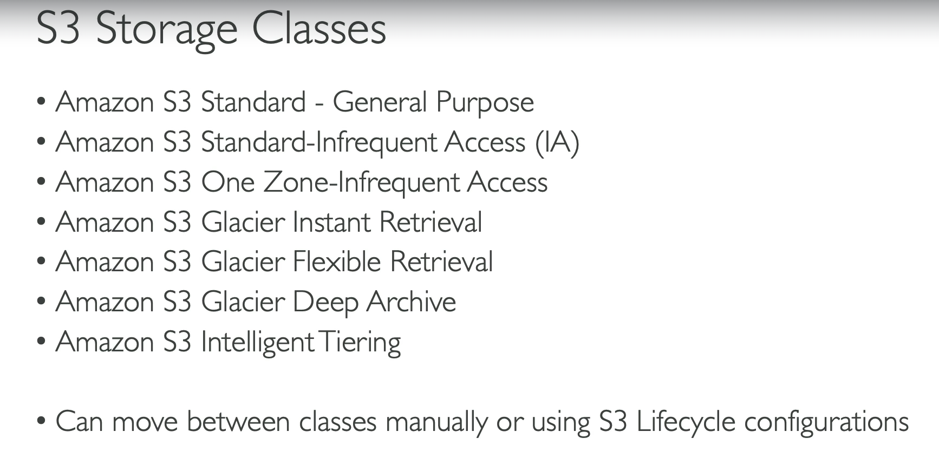

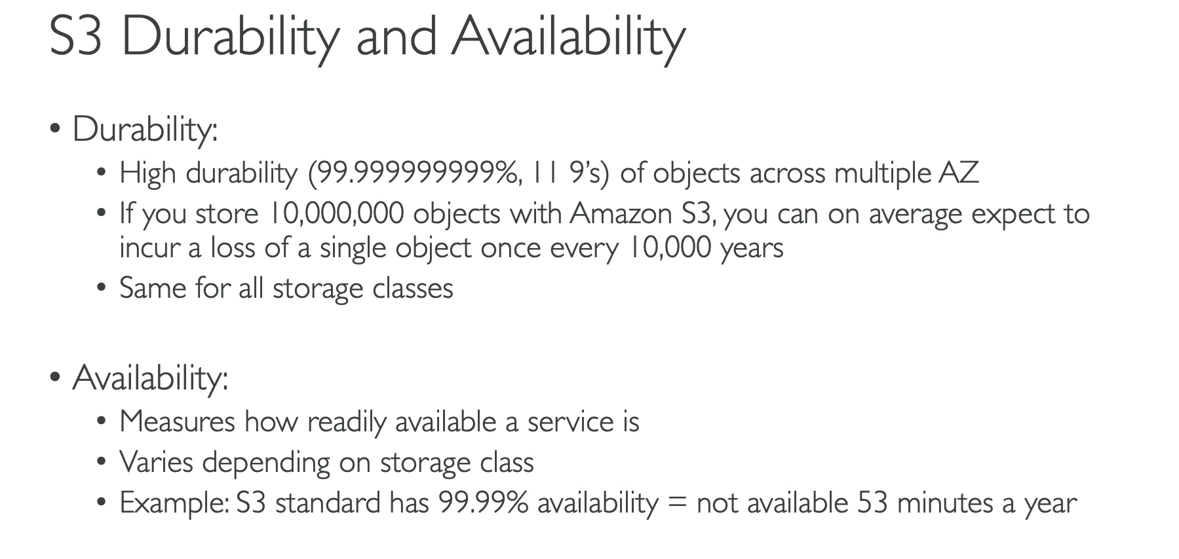

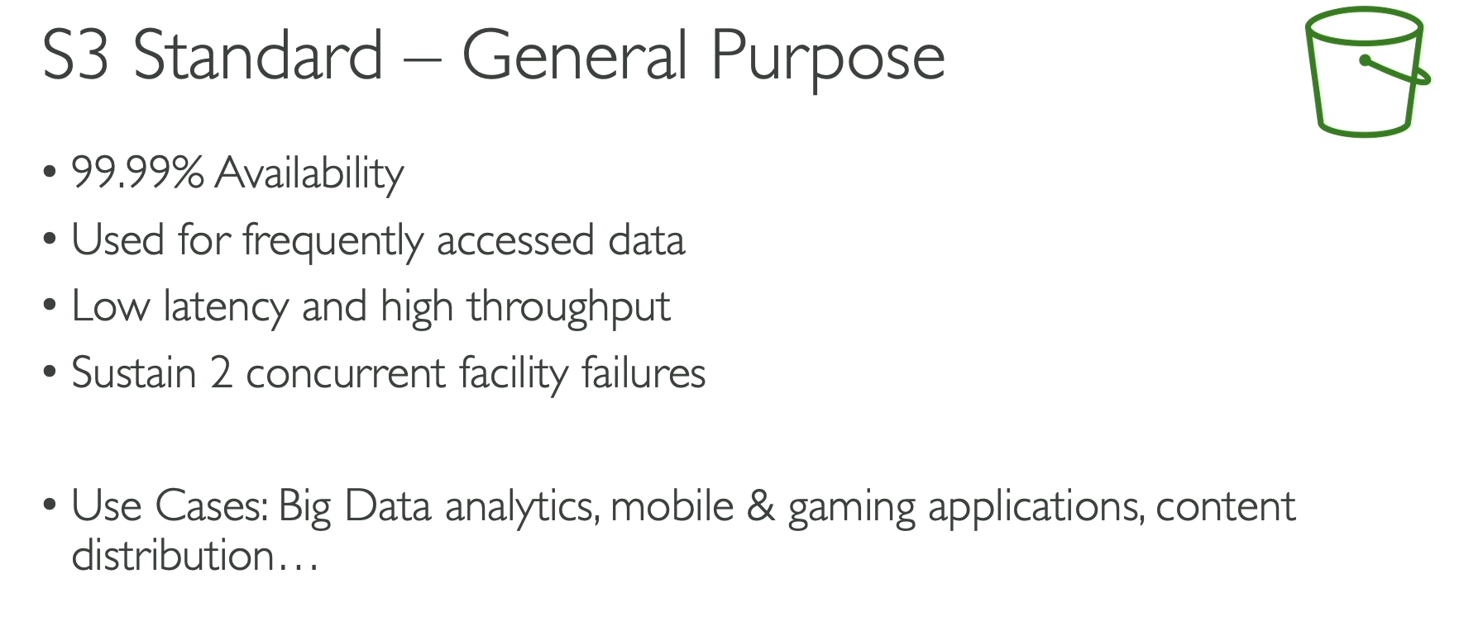

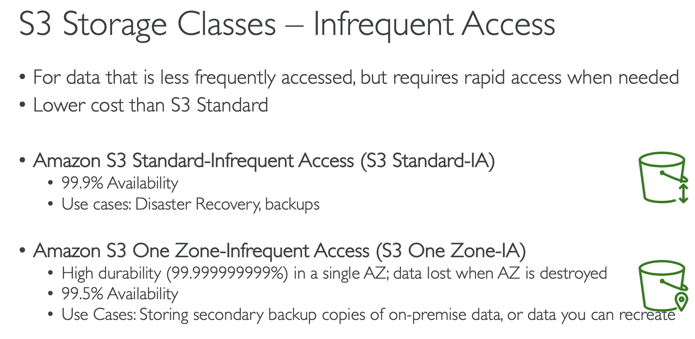

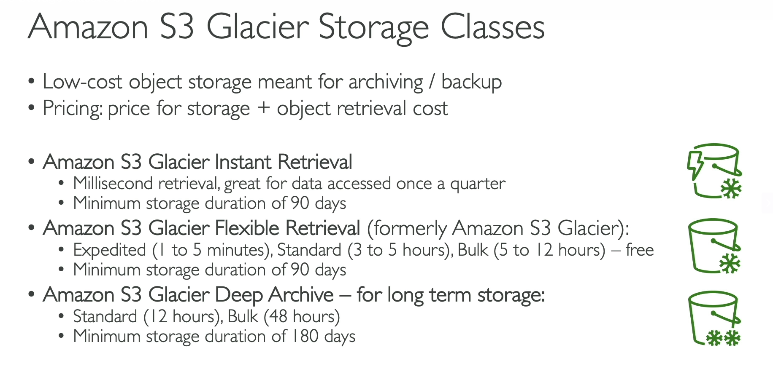

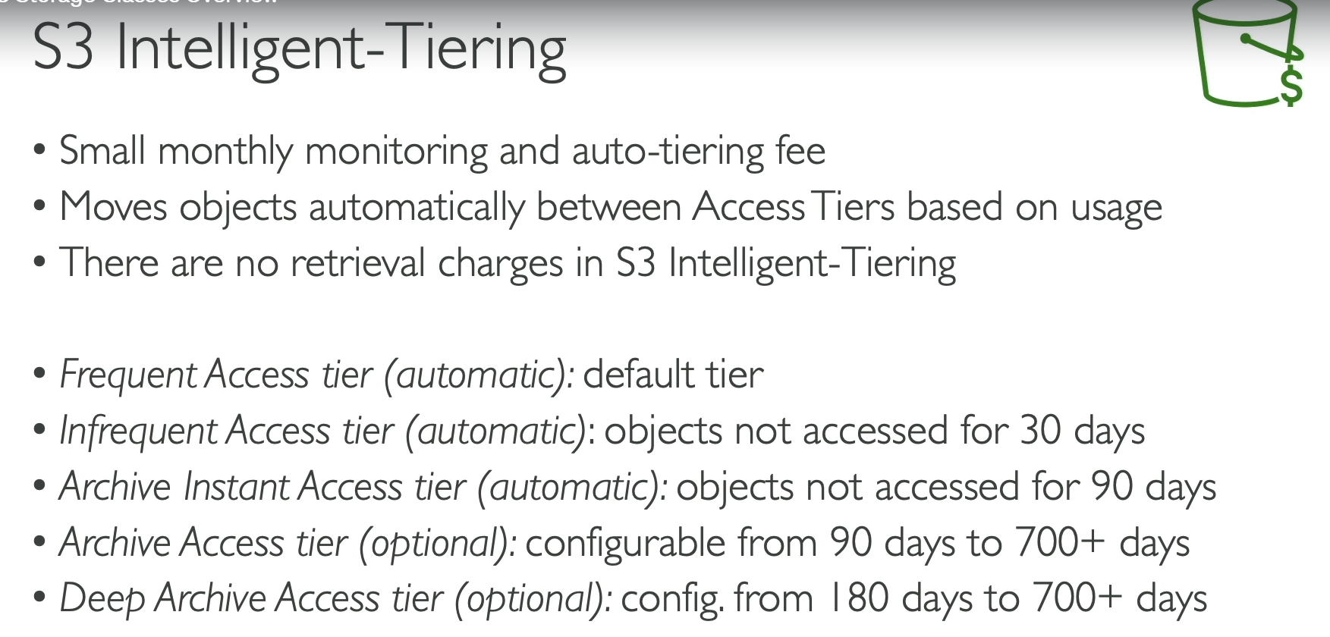

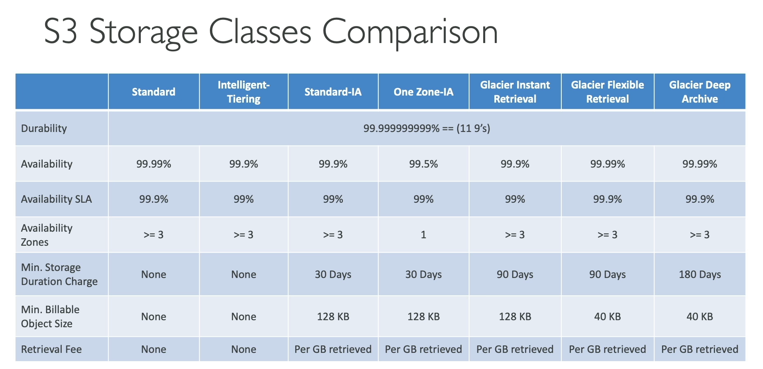

Amazon S3 offers a variety of storage classes, each designed for specific use cases based on data access patterns and cost. A key concept to understand is that all S3 storage classes share the same **11 nines of durability**, meaning data is extremely unlikely to be lost. However, their **availability** and **cost** differ significantly.

**S3 Standard - General Purpose**

* **Best for:** Frequently accessed data.
* **Characteristics:** High availability (99.99%), low latency, high throughput. This is the default storage class.
* **Cost:** Highest cost per GB among the non-Glacier classes, but no retrieval fees.
* **Use Cases:** Big data analytics, mobile and gaming applications, content distribution.

**S3 Infrequent Access (IA)**

* **Best for:** Long-lived, less frequently accessed data that needs to be retrieved quickly when needed.
* **Characteristics:** Lower cost than S3 Standard, but with a **retrieval fee**.
* **Availability:** 99.9%
* **Types:**
  + **S3 Standard-IA:** Stored across multiple Availability Zones (AZs) to withstand failures.
  + **S3 One Zone-IA:** Stored in a single AZ, making it less durable but cheaper. Data is lost if the AZ is destroyed.

**S3 Glacier Storage Classes**

* **Best for:** Archiving and long-term backups. These classes are the cheapest but have a retrieval cost and a time delay.
* **Characteristics:** Very low cost per GB, with retrieval costs and specific retrieval times.
* **Types:**
  + **S3 Glacier Instant Retrieval:** Millisecond retrieval time. Best for data accessed once a quarter. Minimum storage duration of 90 days.
  + **S3 Glacier Flexible Retrieval:** Offers flexible retrieval options from a few minutes to several hours.
    - **Expedited:** 1-5 minute retrieval.
    - **Standard:** 3-5 hour retrieval.
    - **Bulk:** 5-12 hour retrieval (cheapest option).
    - Minimum storage duration of 90 days.
  + **S3 Glacier Deep Archive:** The lowest-cost storage class. Meant for long-term archiving (e.g., 7-10 years).
    - **Standard:** 12-hour retrieval.
    - **Bulk:** 48-hour retrieval.
    - Minimum storage duration of 180 days.

**S3 Intelligent-Tiering**

* **Best for:** Data with unknown or changing access patterns.
* **Characteristics:** Automatically moves objects between different access tiers (frequent, infrequent, archive) based on usage, with no retrieval fees. This is a "set it and forget it" solution.
* **Cost:** Incurs a small monthly monitoring and auto-tiering fee.
* **How it Works:**
  + **Frequent Access Tier:** Default tier.
  + **Infrequent Access Tier:** Objects not accessed for 30 days are automatically moved here.
  + **Archive Instant Access Tier:** Objects not accessed for 90 days are moved here.
  + **Archive and Deep Archive Tiers:** Optional tiers you can configure for objects not accessed for longer periods (e.g., 90+ days or 180+ days).

1. **S3 Storage Classes Hands On:**

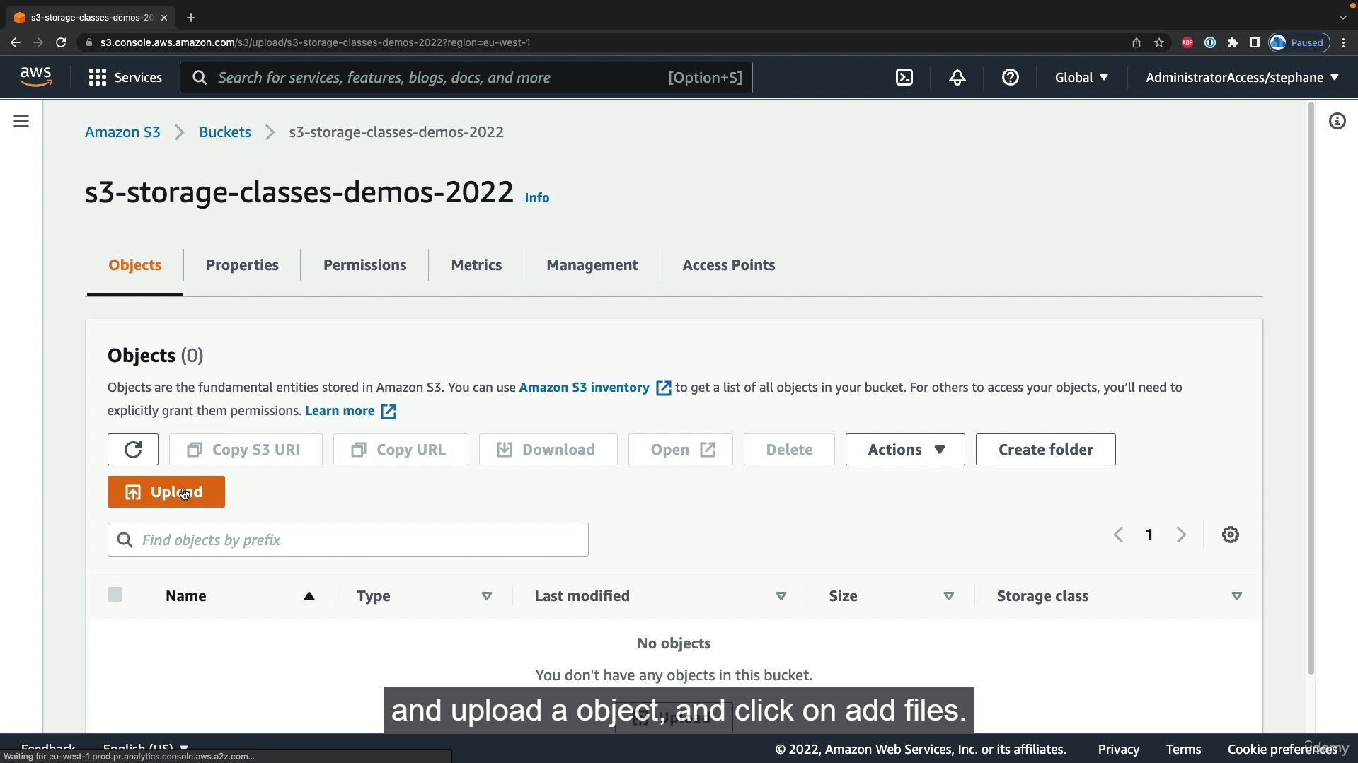

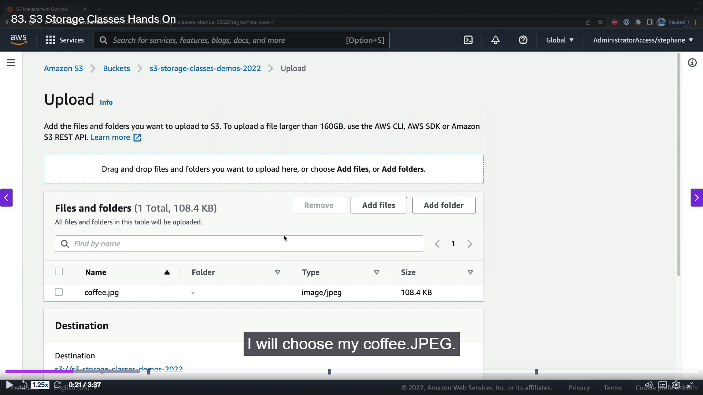

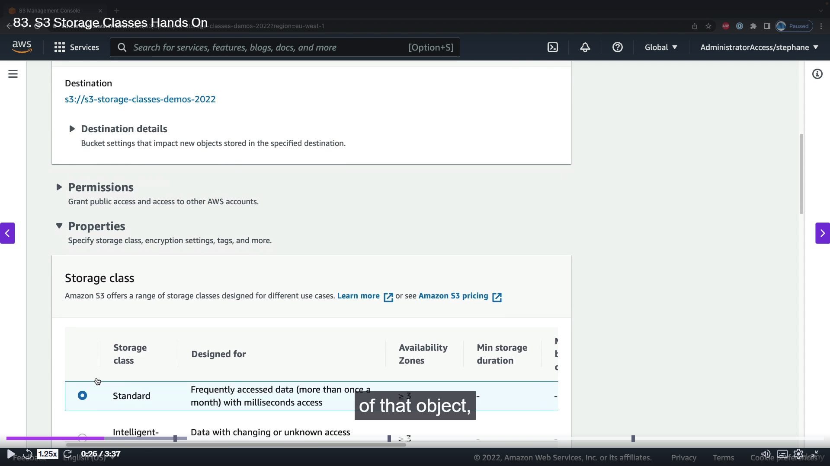

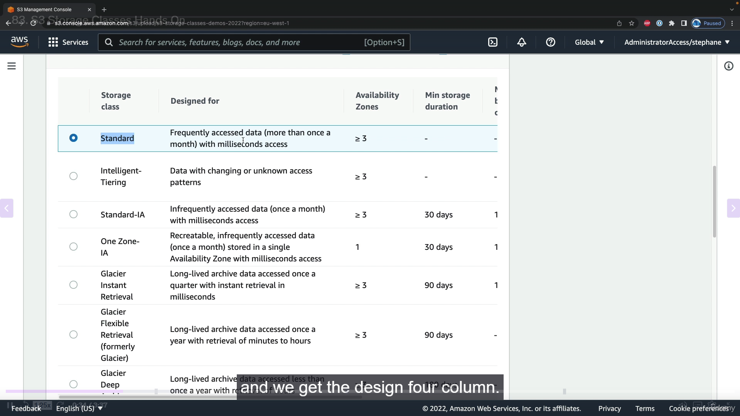

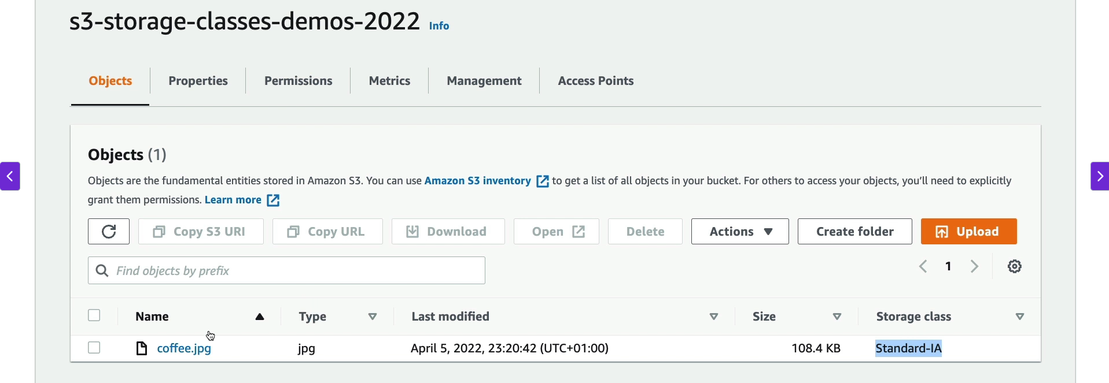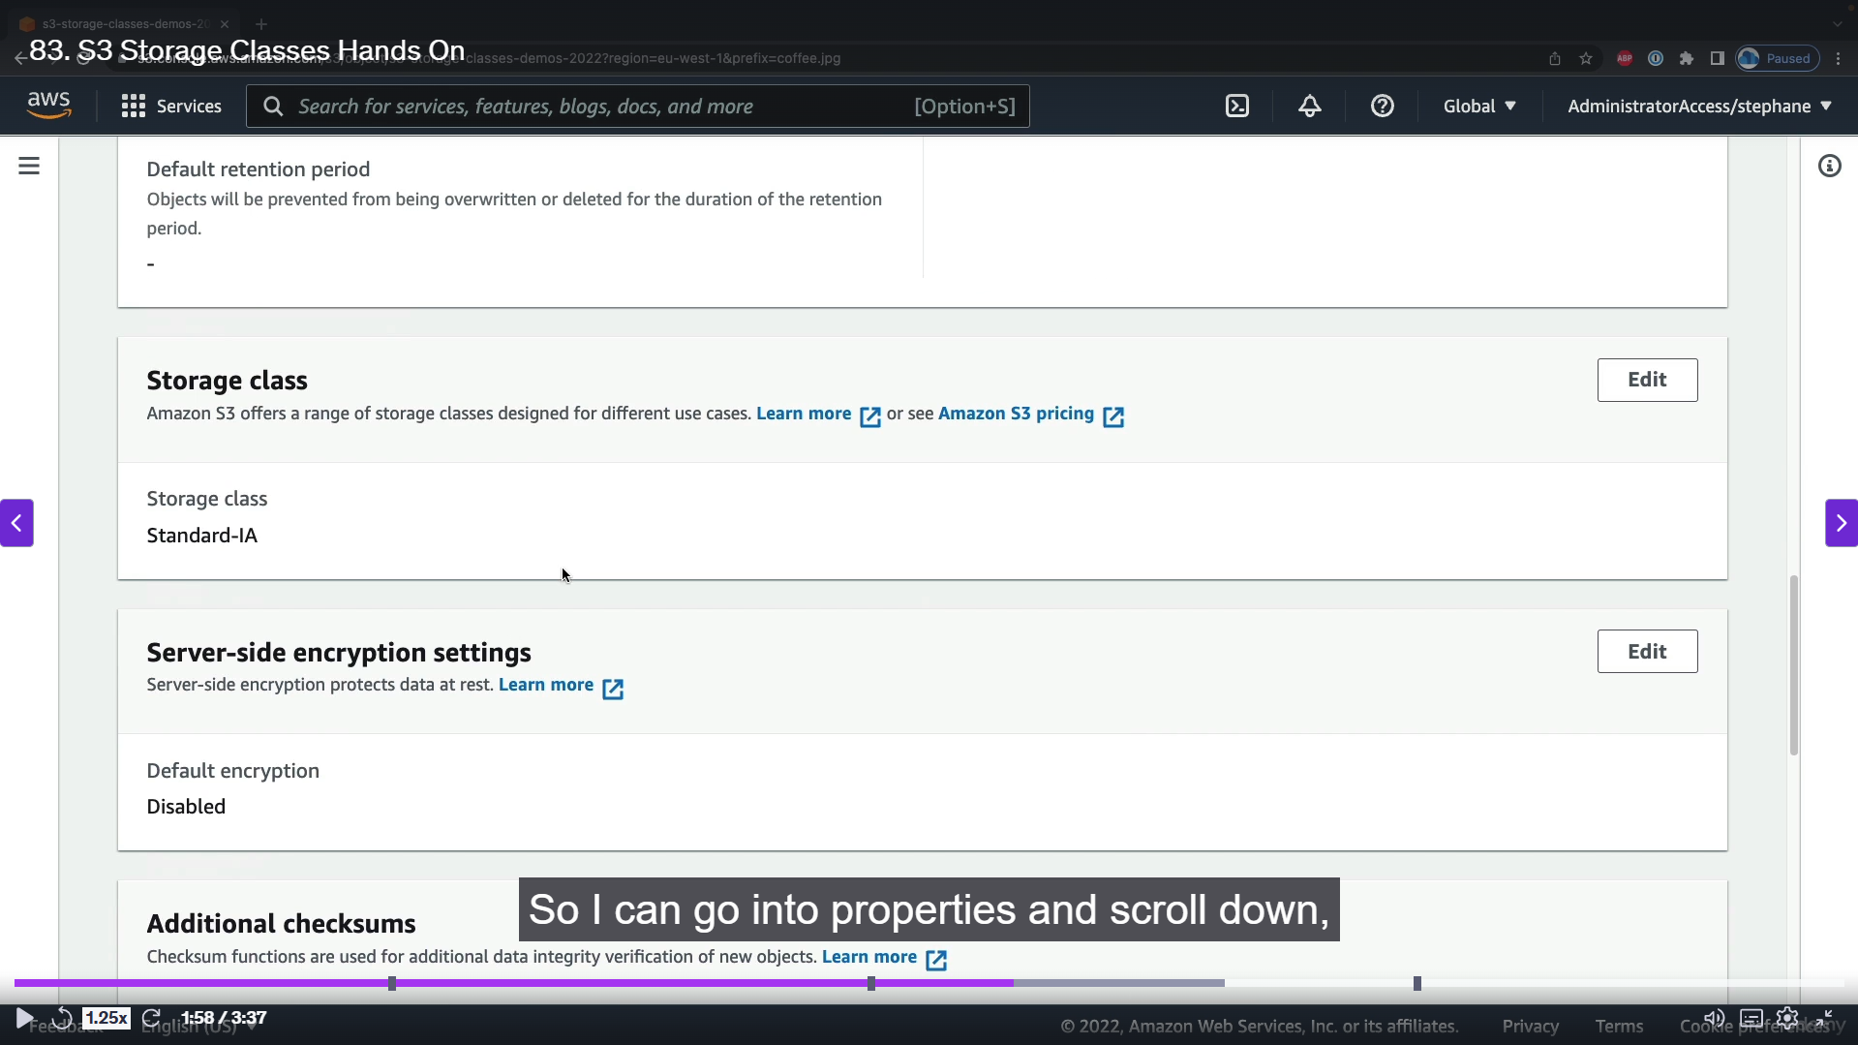

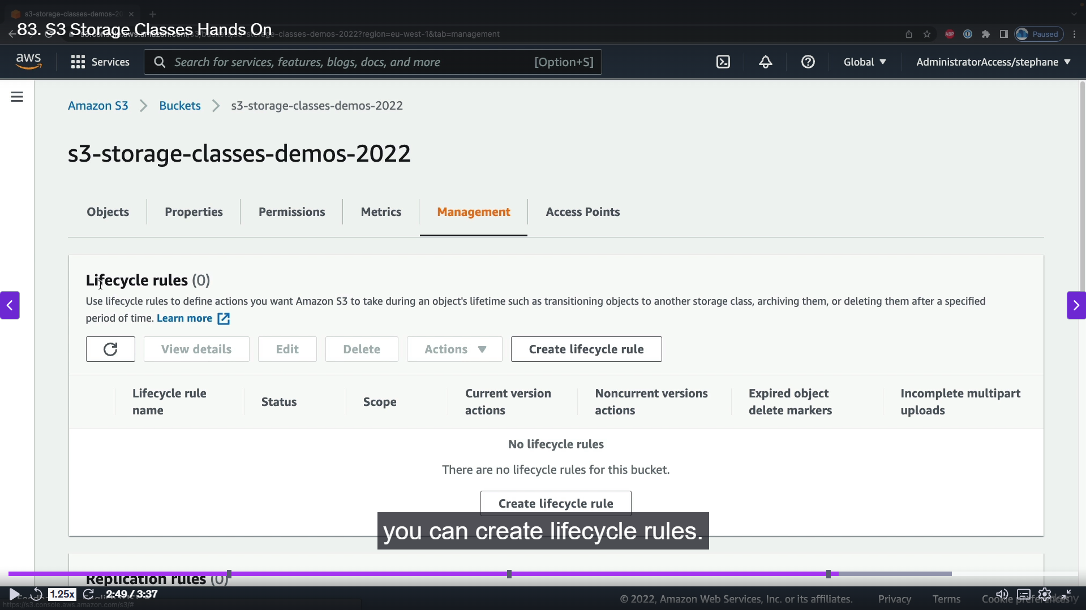

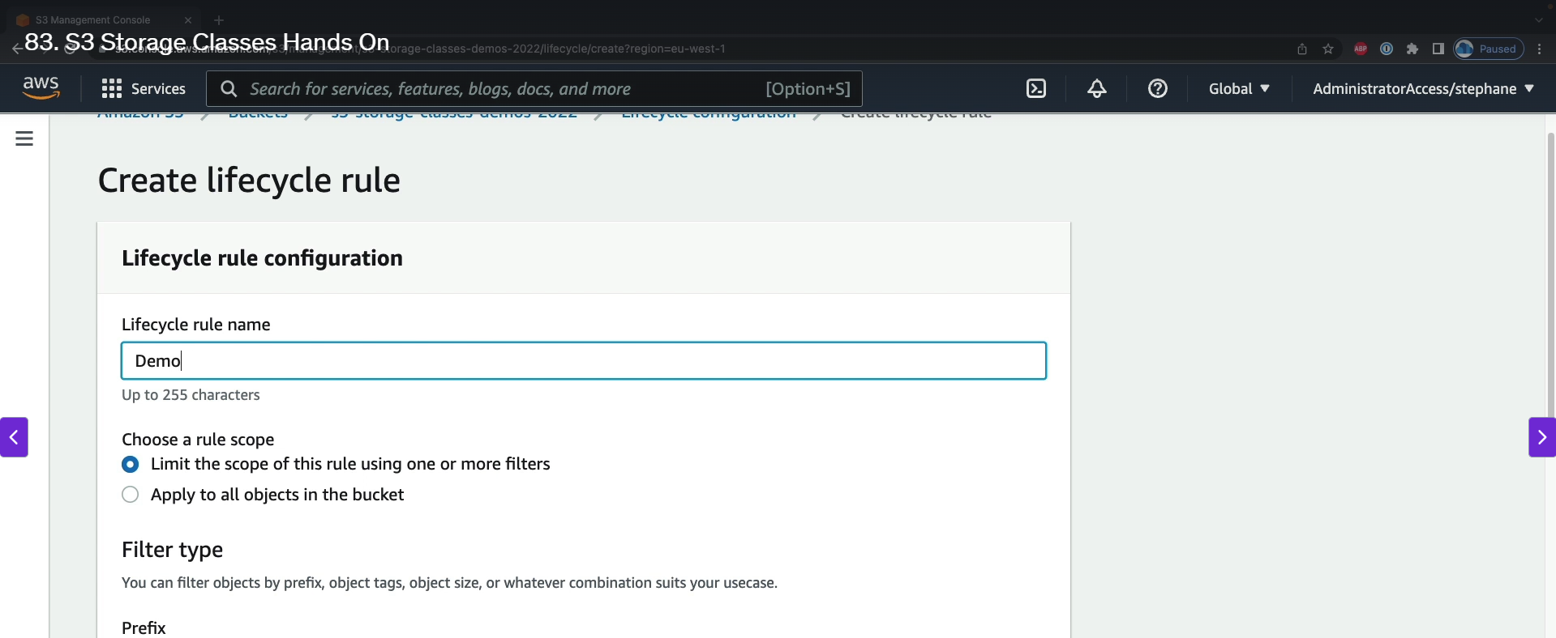

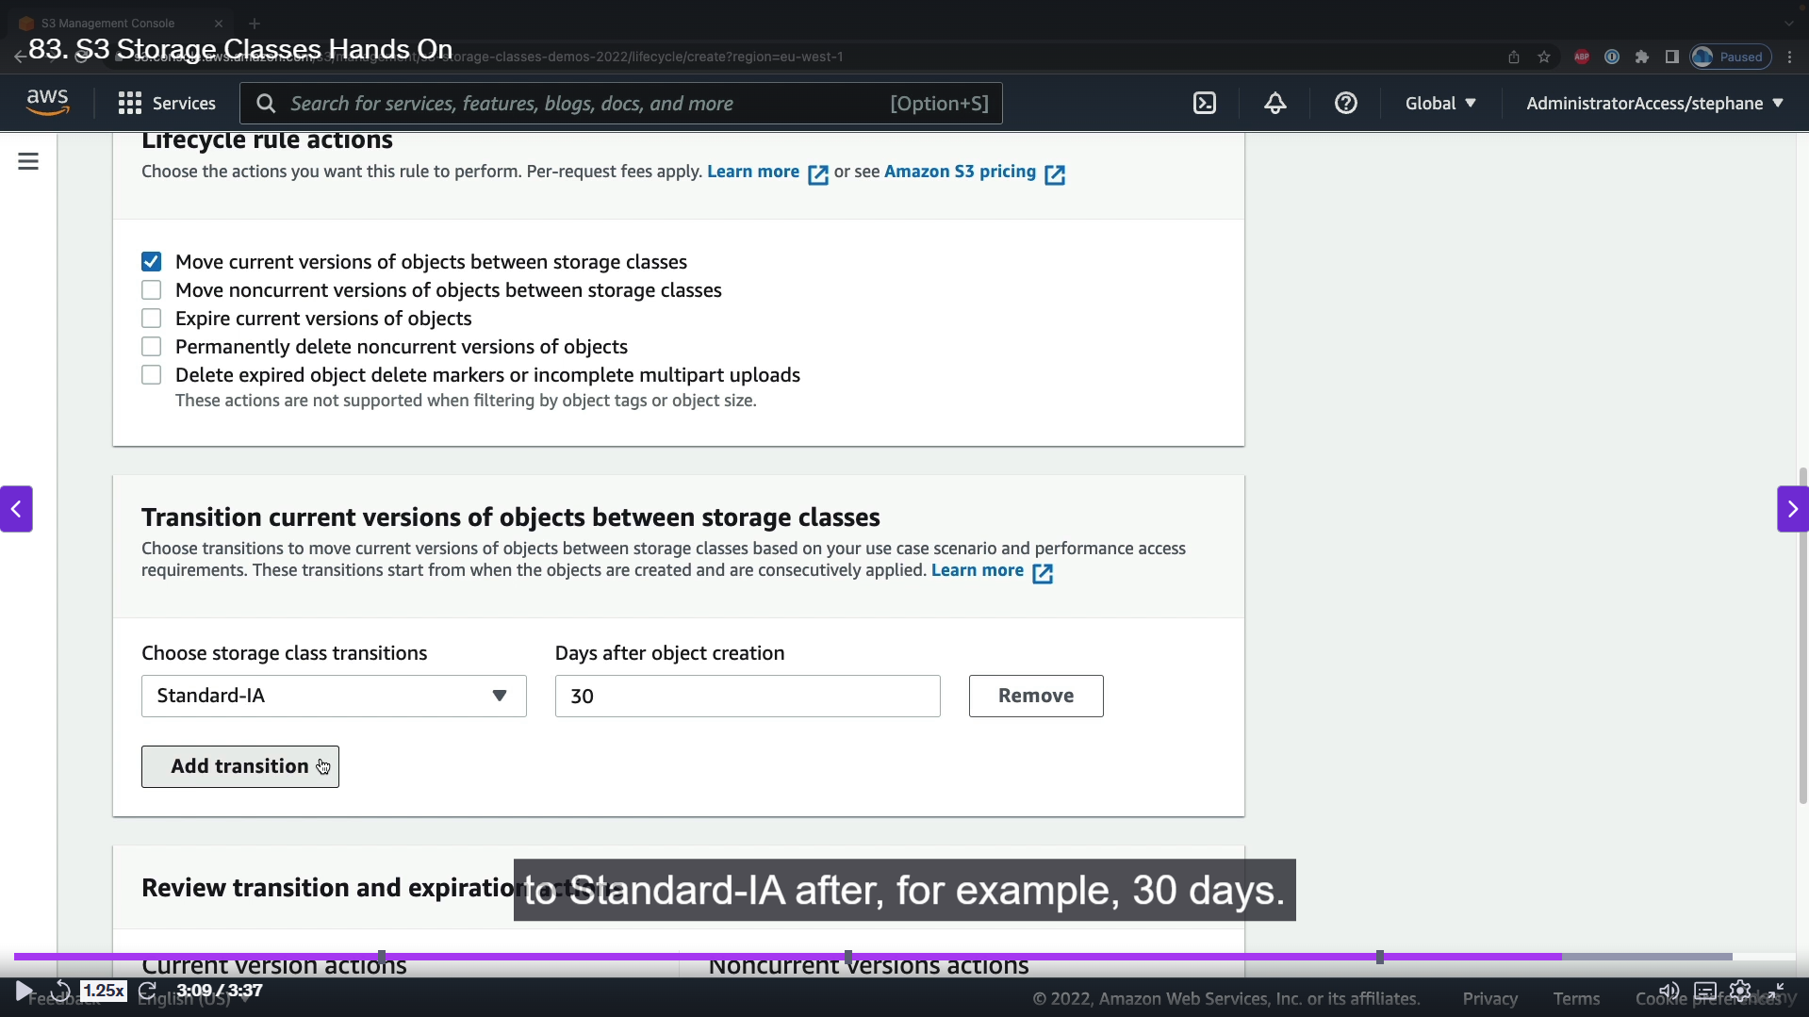

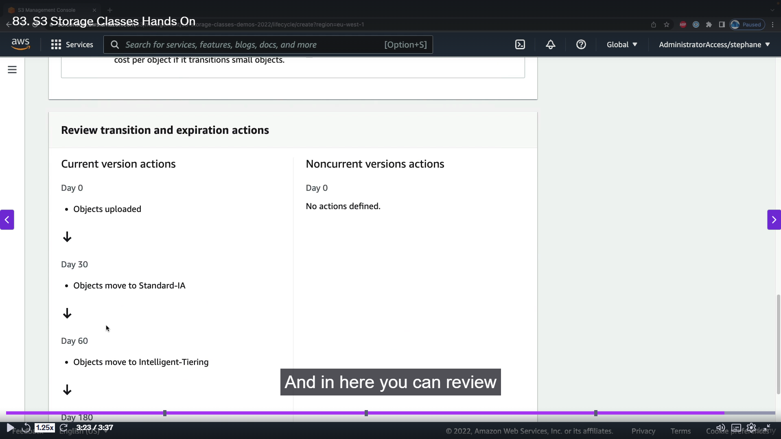

**Step-by-Step Guide to S3 Storage Classes**

**Part 1: Uploading an Object with a Specific Storage Class**

1. **Create an S3 Bucket:** Create a new S3 bucket with a unique name (e.g., s3-storage-classes-demos-2022). You can choose any AWS region.
2. **Upload an Object:** Go into your newly created bucket and click on "Upload." Add a file (e.g., coffee.jpeg).
3. **Choose a Storage Class:** During the upload process, you will see an "Options" section. Under "Storage Class," you can select a specific tier for your object. The options include:
   * **S3 Standard:** For frequently accessed data.
   * **S3 Intelligent-Tiering:** Automatically moves objects between tiers based on access patterns.
   * **S3 Standard-IA (Infrequent Access):** For data that is accessed less frequently but needs fast retrieval.
   * **S3 One Zone-IA:** Similar to Standard-IA but stores data in a single Availability Zone, making it cheaper but less durable.
   * **S3 Glacier Instant Retrieval, Flexible Retrieval, and Deep Archive:** For long-term archiving with varying retrieval times and costs.
   * **Reduced Redundancy:** A deprecated storage class.
4. **Complete the Upload:** Select your desired storage class (e.g., Standard-IA) and complete the upload. The object will now be stored in the chosen tier.

**Part 2: Manually Changing an Object's Storage Class**

1. **Select the Object:** In your S3 bucket, click on the object whose storage class you want to change.
2. **Edit Properties:** Go to the "Properties" tab of the object and scroll down to the "Storage class" section. Click "Edit."
3. **Change the Class:** Choose a new storage class from the list (e.g., One-Zone-IA or Glacier-Instant-Retrieval).
4. **Save Changes:** Click "Save changes." The object's storage class will be updated in place without needing a new upload. This demonstrates the flexibility of S3's object-level storage class management.

**Part 3: Automating Storage Class Transitions with a Lifecycle Rule**

1. **Go to "Management" Tab:** In your S3 bucket, navigate to the "Management" tab.
2. **Create a Lifecycle Rule:** Find the "Lifecycle rules" section and click "Create rule."
3. **Name and Scope the Rule:** Give the rule a name (e.g., DemoRule) and choose to apply it to all objects in the bucket.
4. **Configure Transitions:** Under the "Lifecycle rule actions," select "Move current versions between storage classes." You can now define a series of transitions based on time. For example:
   * Transition to Standard-IA after 30 days.
   * Transition to Glacier-Flexible-Retrieval after 180 days.
5. **Review and Create:** The console will show you a visual representation of your configured transitions. Review the settings and click "Create rule." The rule will now automatically transition objects to different storage classes based on the number of days since their creation, helping you optimize costs over time.
6. **S3 Express One Zone:**

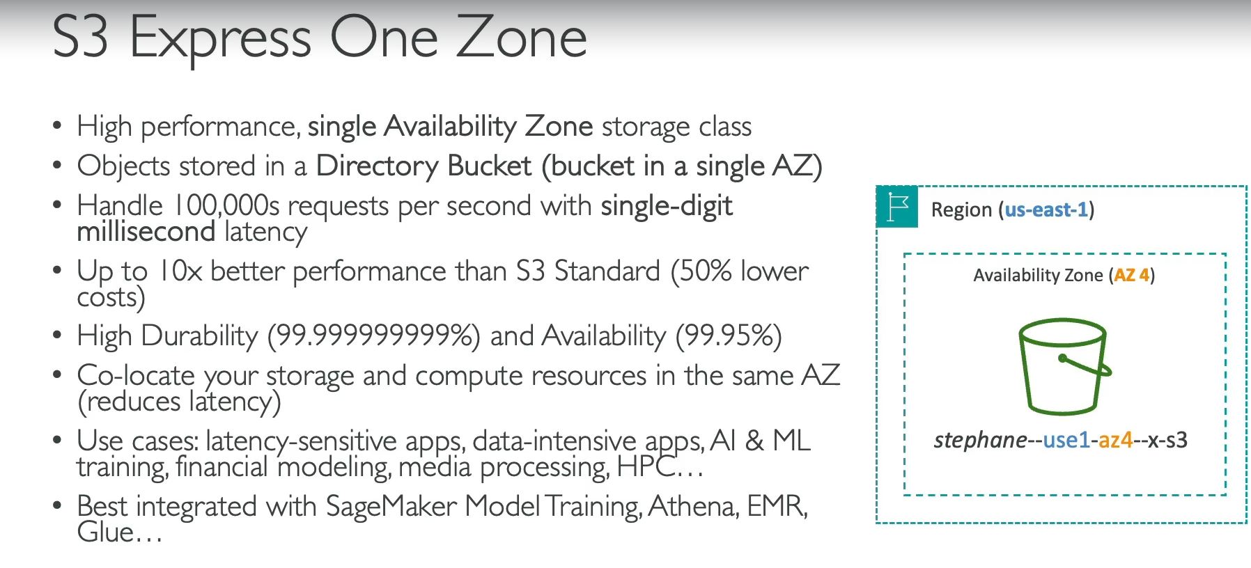

The S3 Express One Zone storage class is a high-performance, single-Availability Zone (AZ) storage solution. It's designed for applications that require extremely low latency and high request rates.

**How it Works**

* **Directory Buckets:** Unlike other S3 classes, S3 Express One Zone stores objects in a special type of container called a **directory bucket**, which is constrained to a single AZ. You choose the specific AZ when you create the bucket.
* **Performance:** By being in a single AZ, it can offer up to **10x better performance** and **50% lower cost** compared to S3 Standard. This allows for hundreds of thousands of requests per second with single-digit millisecond latency.
* **Availability vs. Durability:** While it maintains the standard S3 durability, its **availability is lower** because all data is stored in a single AZ. This makes it vulnerable to a complete AZ failure, which would directly impact your data's accessibility.
* **Colocation:** A key benefit is the ability to **collocate your computer resources and storage** in the same AZ. This minimizes network latency and can reduce data transfer costs between services.

**Use Cases**

This storage class is ideal for applications that are highly sensitive to latency and require immense speed.

* **Data-intensive Applications**
* **AI/ML Training**
* **Financial Modelling**
* **Media Processing**
* **High-Performance Computing (HPC)**

1. **S3 Encryption:**

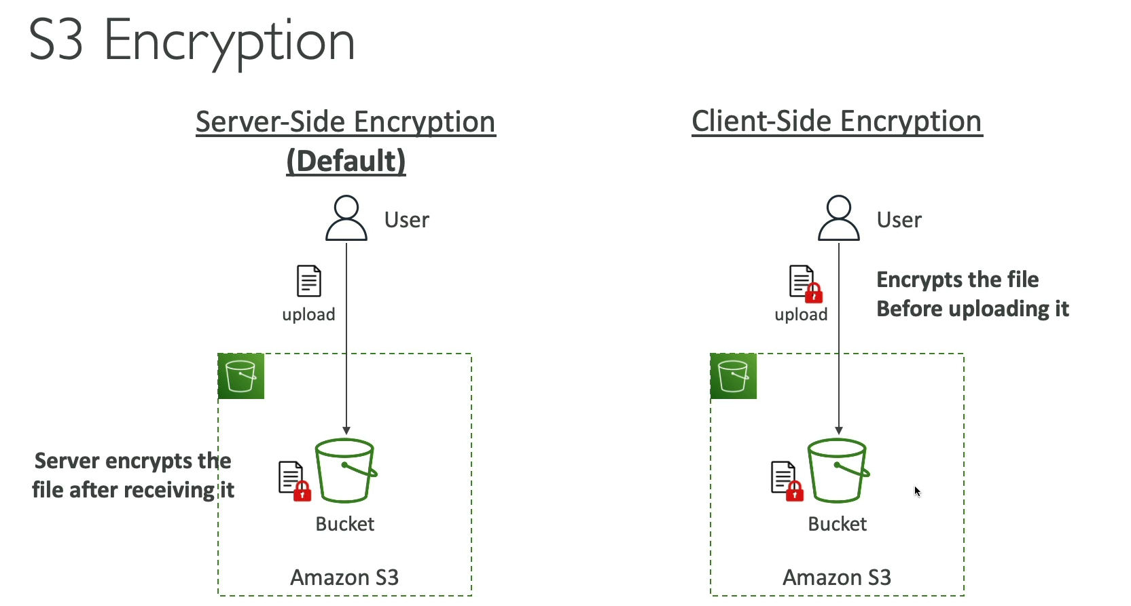

In S3, data encryption can be managed in two main ways: server-side or client-side. The key difference lies in where the encryption process happens.

**Server-Side Encryption (SSE)**

With SSE, the encryption happens on the **AWS S3 servers** after the object has been uploaded. This is the **default** behavior for all new S3 buckets.

1. A user uploads an object to S3 in its original, unencrypted form.
2. Upon receiving the object, S3 automatically encrypts it before storing it.
3. When a user downloads the object, S3 automatically decrypts it before sending it back.
4. This method protects data **at rest** within the S3 service.

There are three types of server-side encryption, which differ based on who manages the encryption keys:

* **SSE-S3**: S3 manages the encryption keys. This is the simplest option.
* **SSE-KMS**: AWS Key Management Service (KMS) manages the keys, providing more control and a log of key usage.
* **SSE-C**: The customer provides their own encryption key for S3 to use during the upload/download process.

**Client-Side Encryption (CSE)**

With CSE, the encryption happens on the **client-side** before the object is uploaded to S3.

1. The user's application or client encrypts the object using an encryption key.
2. The already-encrypted object is then uploaded to S3.
3. When the user downloads the object, their application must decrypt it.
4. This method provides **end-to-end encryption**, protecting the data in transit and at rest, and gives the customer full control over the encryption process and keys.
5. **IAM Access Analyzer for S3:**

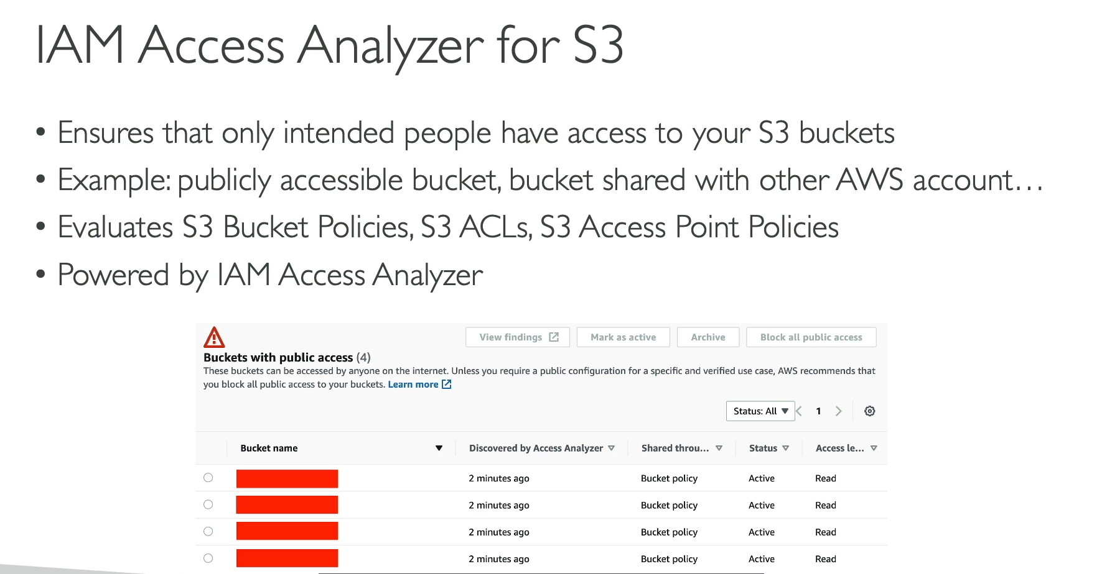

IAM Access Analyzer for Amazon S3 is a security monitoring feature that helps you ensure your S3 buckets are not being accessed by unintended external entities. It works by continuously analyzing your S3 bucket policies, Access Control Lists (ACLs), and S3 Access Point policies.

**How It Works**

* **Continuous Analysis:** The service scans your bucket's access policies to identify any configurations that grant public or cross-account access.
* **Findings:** If it detects a policy that makes a bucket publicly accessible or shared with another AWS account, it generates a "finding."
* **Actionable Insights:** These findings are then surfaced to you in a dashboard, allowing you to review the access and determine if it's intentional. If it's an unintended security risk, you can take immediate action to remediate it.
* **Underlying Service:** This feature is powered by the broader **IAM Access Analyzer** service, which can find resources across your entire AWS account that are shared with other entities outside of your "trusted zone."

1. **Shared Responsibility Model for S3:**

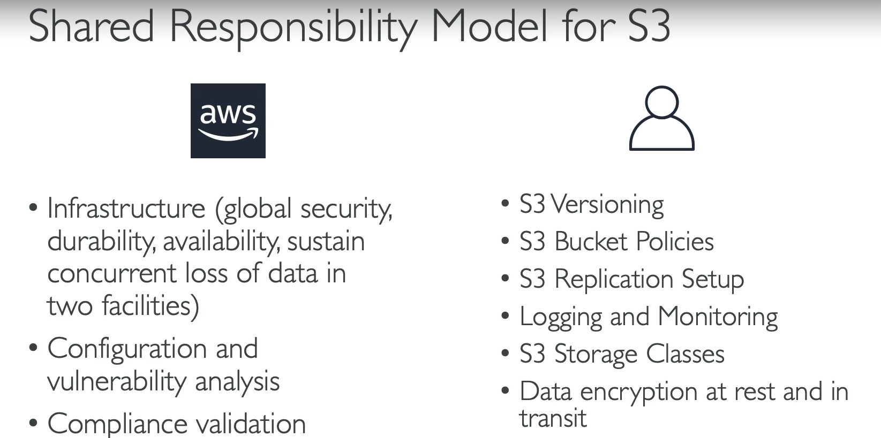

1. **AWS Snow family Overview:**

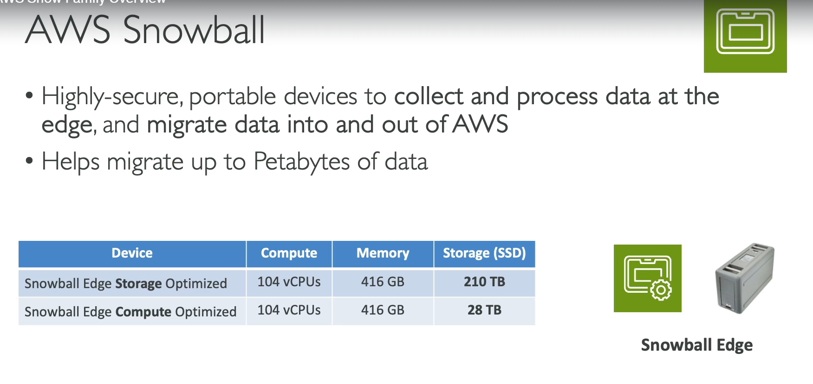

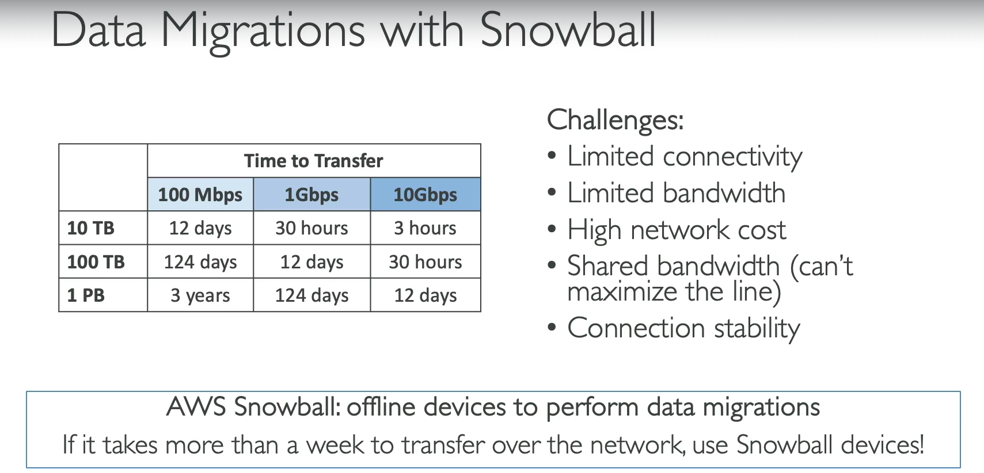

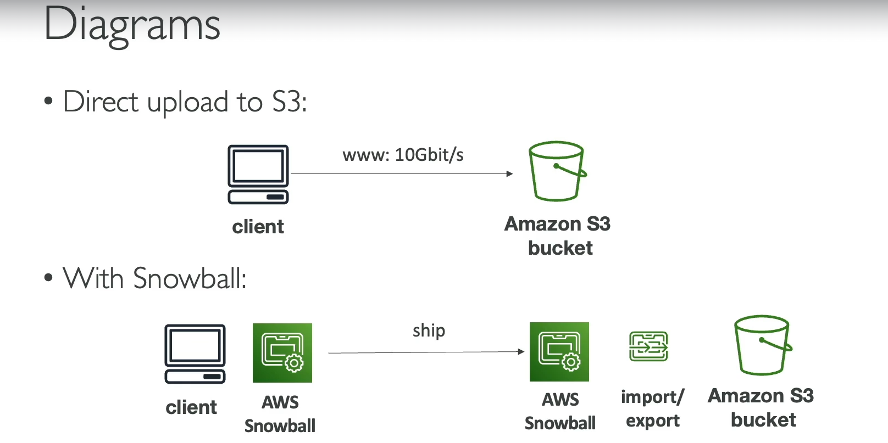

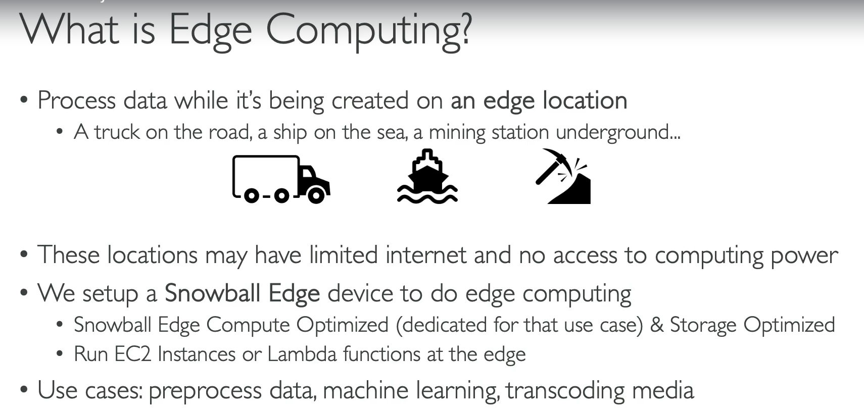

AWS Snowball is a physical device used to securely transfer large amounts of data to and from the AWS cloud, as well as to perform on-site edge computing in environments with limited or no connectivity. It's an ideal solution when transferring data over a network is too slow, expensive, or unreliable.

**Data Migration**

For large-scale data transfers, the traditional network approach can be a significant bottleneck.

* **Process:** You order a **Snowball** device from AWS, which is physically shipped to you. You then connect it to your local network and transfer your data onto the device. Once the transfer is complete, you ship the device back to AWS, where your data is loaded into your designated AWS service, like S3.
* **When to Use:** Snowball is recommended when a data transfer would take more than a week over your current network connection. It saves time, network bandwidth, and can be more cost-effective than high-cost network connections.

**Edge Computing**

Snowball Edge devices also provide on-board computing capabilities, allowing you to process data locally at the source.

* **Purpose:** This is for situations where you need to analyze or process data in remote or disconnected locations before sending it to the cloud. This includes environments like trucks, ships, or remote research sites.
* **On-board Compute:** Snowball Edge devices can run **EC2 instances** and **AWS Lambda functions** directly on the device itself.
* **Benefits:** This allows you to pre-process data, perform machine learning inference, or transcode media at the edge, reducing the amount of data that needs to be transferred to the cloud.

**Snowball Device Types**

There are two main types of Snowball Edge devices, each optimized for a different primary use case:

* **Snowball Edge Storage Optimized:** Provides significant storage capacity (e.g., 210 TB) with some compute functionality. It's designed for **large-scale data migration**.
* **Snowball Edge Compute Optimized:** Offers higher compute power with less storage (e.g., 28 TB). It's built for **edge computing workloads** that require powerful processing.

1. **AWS Snow family Hands On:**

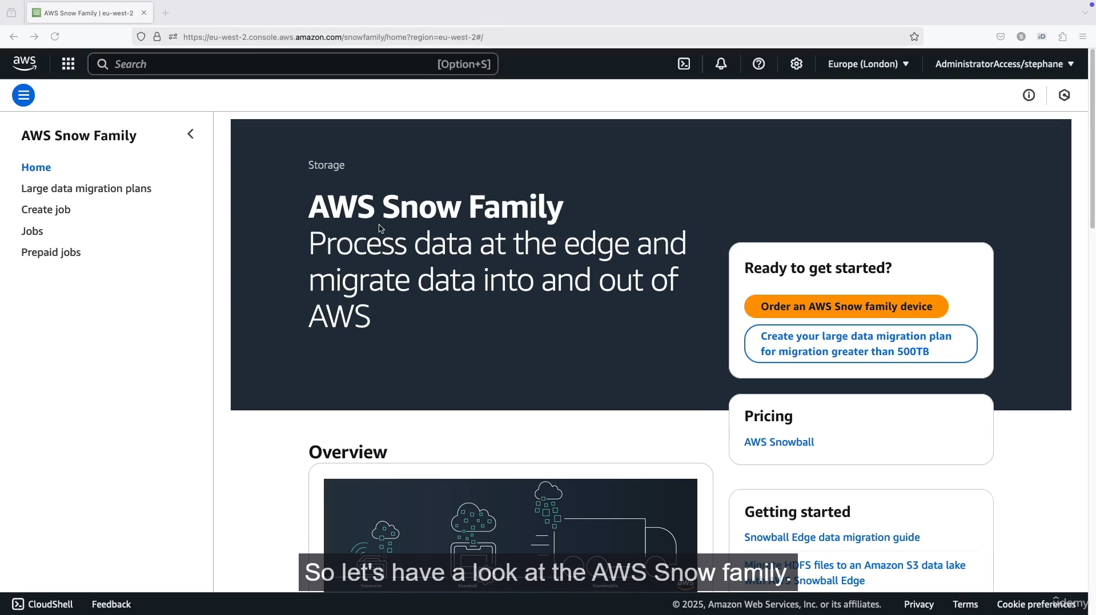

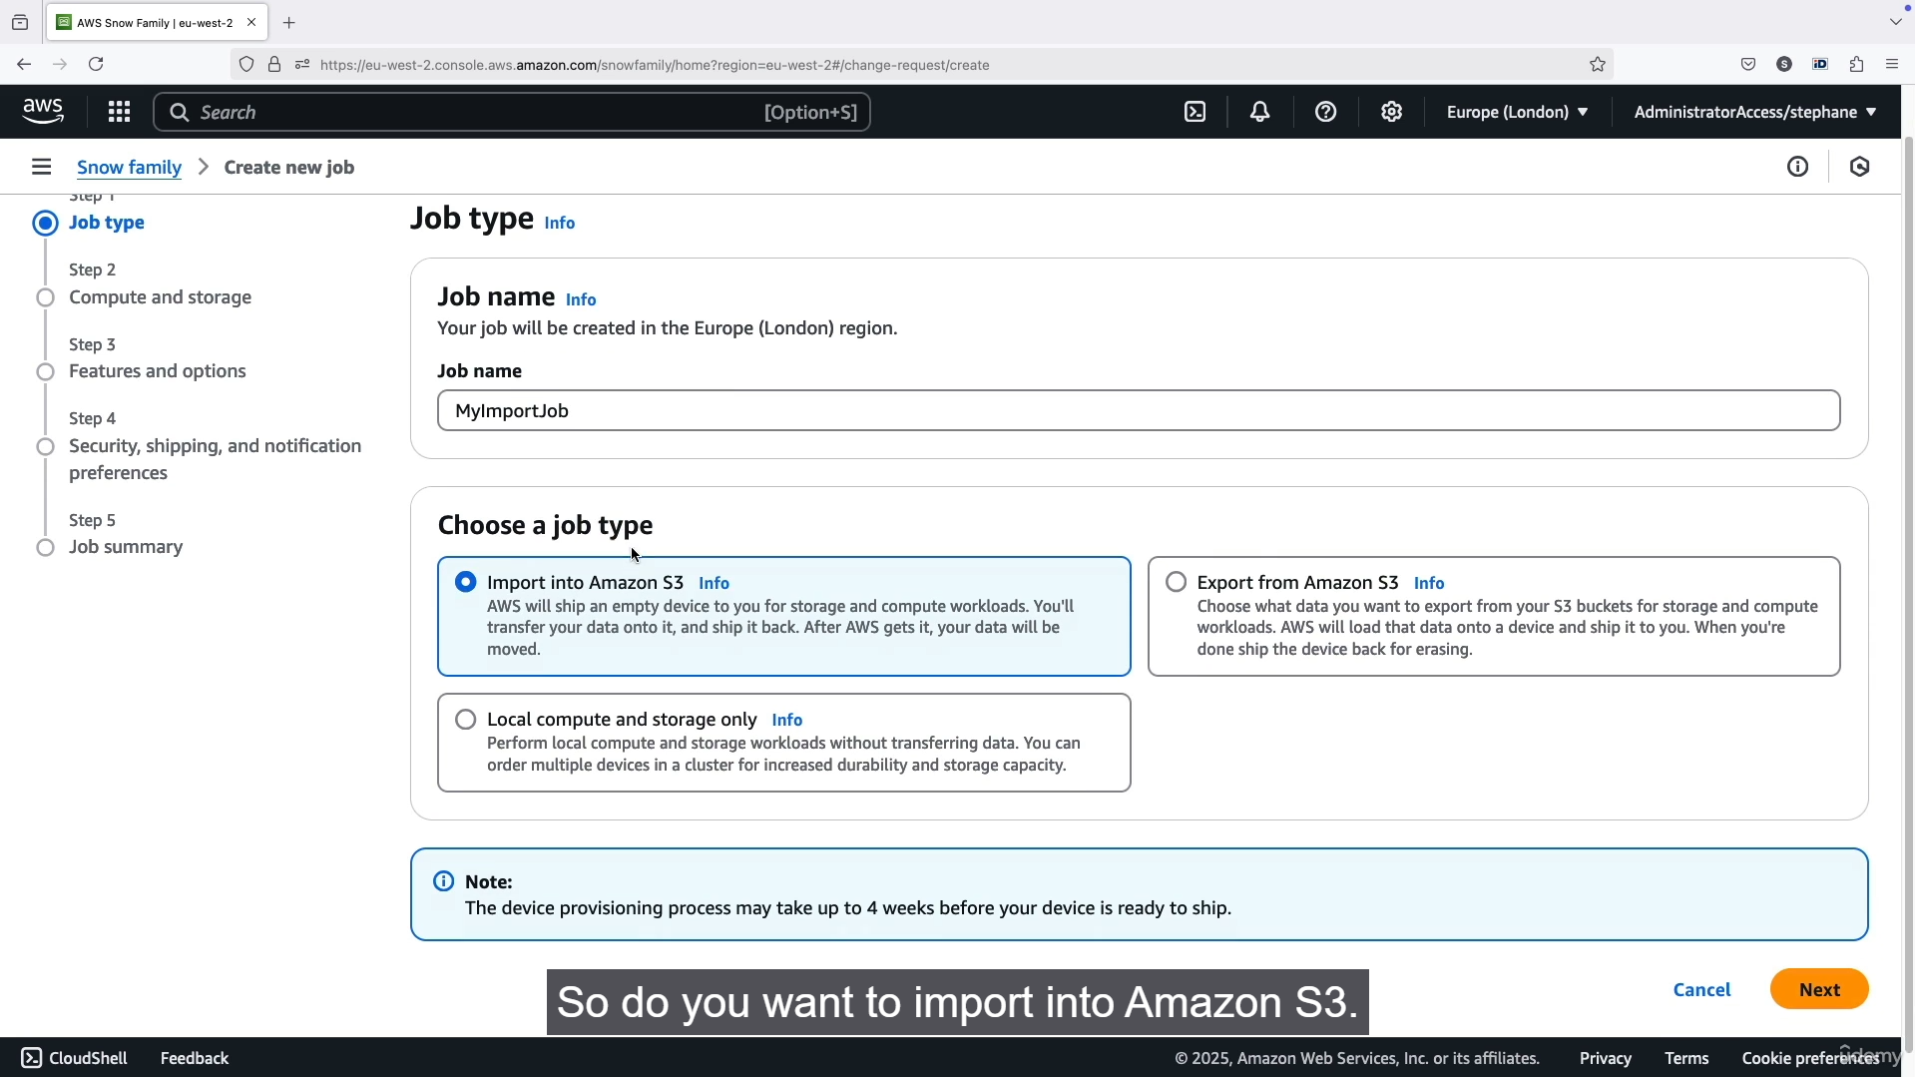

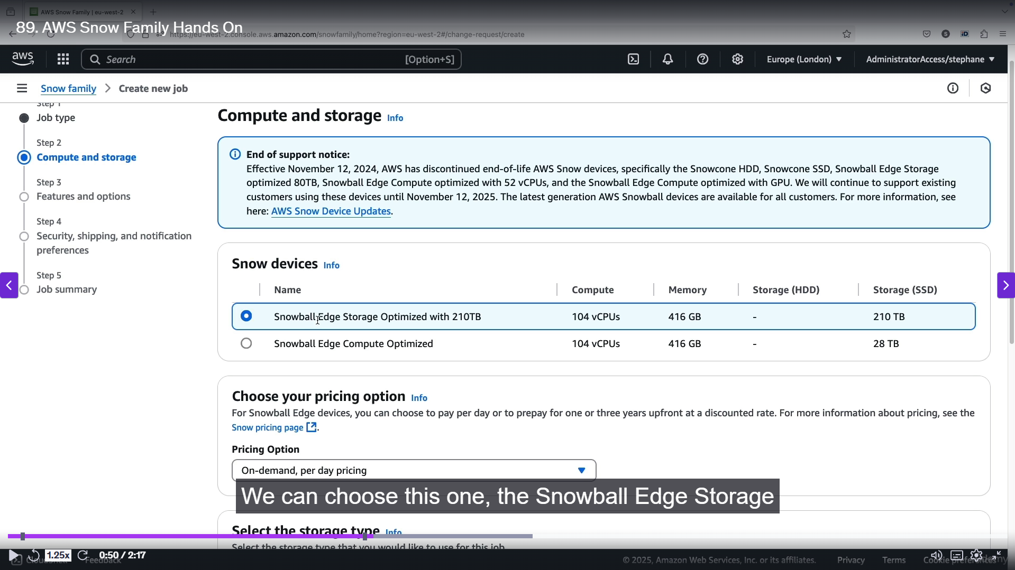

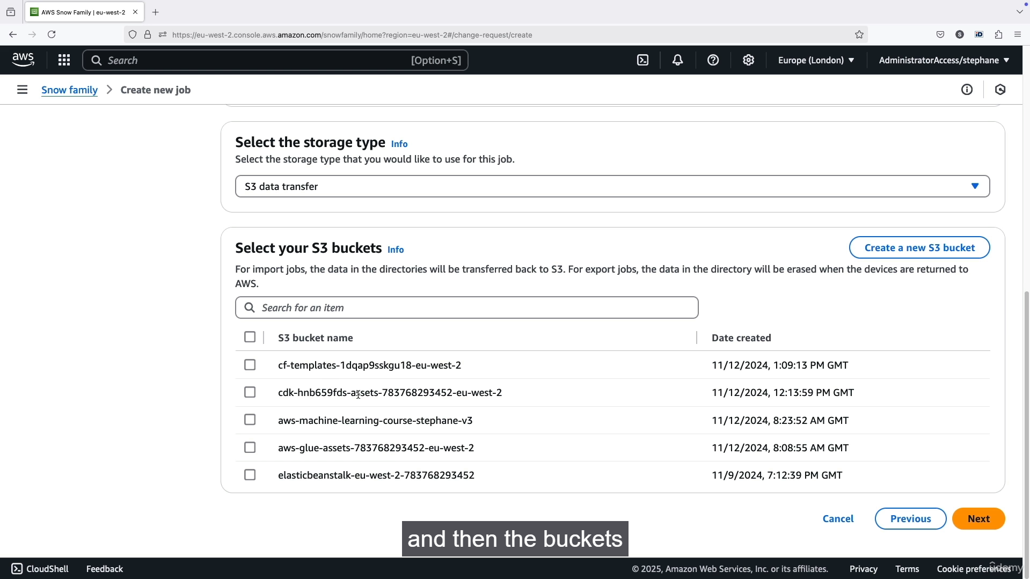

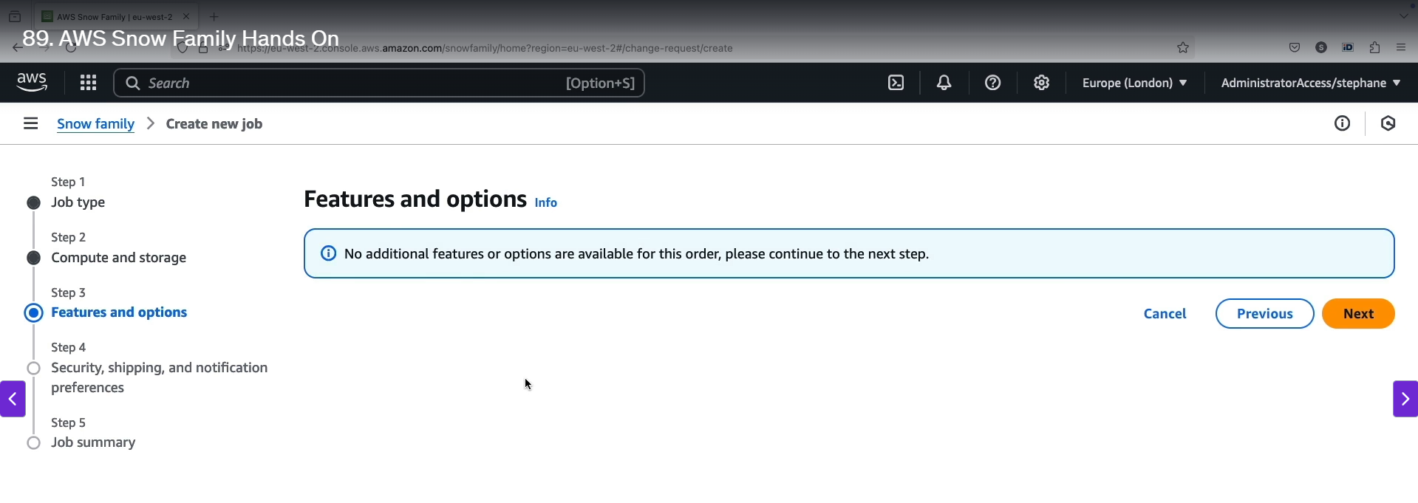

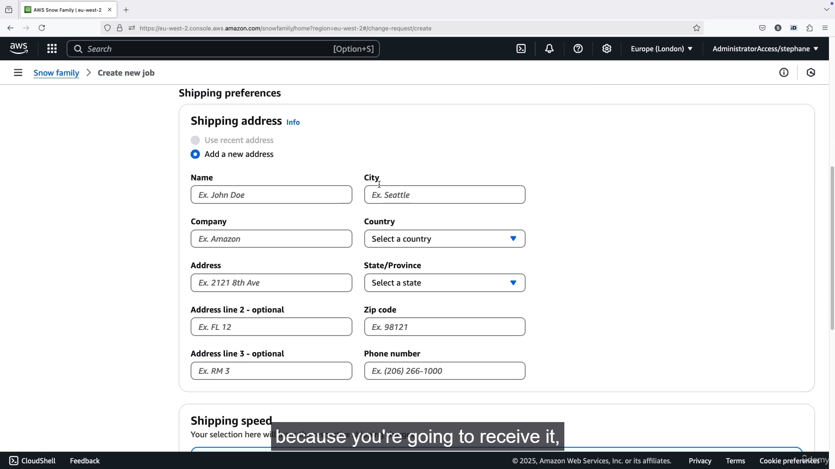

**Step-by-Step Guide to Ordering an AWS Snow Family Device**

1. **Start a New Job:** Go to the AWS Snow Family console and begin the process of creating a new job. This process is a guided wizard.
2. **Define Job Type:** Choose one of the following job types:
   * **Import into Amazon S3:** You will receive a device, load your data onto it, and ship it back to AWS to have the data uploaded to your specified S3 bucket. This is the most common use case for migrating on-premises data to the cloud.
   * **Export from Amazon S3:** AWS will load your S3 data onto the device and ship it to you. You then transfer the data from the device to your local systems.
   * **Local Compute and Storage Only:** This option is for edge computing where you want to use the device's compute and storage capabilities at your local location without transferring data to or from AWS.
3. **Select a Snow Device:** Choose the appropriate device for your needs. The two main options are:
   * **Snowball Edge Storage Optimized:** Designed for large-scale data transfer with a focus on storage capacity (e.g., 210 TB).
   * **Snowball Edge Compute Optimized:** Has a focus on powerful compute capabilities for local data processing and edge computing (e.g., for machine learning or video analysis).
4. **Configure Pricing and Destination:**
   * **Pricing:** You can choose an on-demand pricing model which includes a service fee and a daily fee after a free period.
   * **S3 Destination:** For an import job, you must specify the Amazon S3 bucket where your data will be uploaded once the device is returned to AWS.
5. **Set Up Security and Permissions:**
   * **Encryption:** The data on the Snow device is encrypted. You will need to choose the encryption options.
   * **IAM Role:** You must create or use an existing IAM service role. This role gives the Snow service permission to write data to your destination S3 bucket on your behalf.
6. **Provide Shipping Details:**
   * **Shipping Address:** Enter the physical address where you want the device to be shipped.
   * **Shipping Speed:** Choose your preferred shipping speed (e.g., one-day or two-day shipping).
7. **Set Up Notifications:** Configure notifications (e.g., via Amazon SNS) to receive updates on your job status, such as when the device is shipped or received by AWS.
8. **Review and Create Job:** A summary of your order will be displayed. Review all the details, including the job type, device, destination bucket, and shipping information. Once you confirm, the job will be created, and AWS will prepare to ship the device to you.
9. **AWS Snowball Edge – Pricing:**

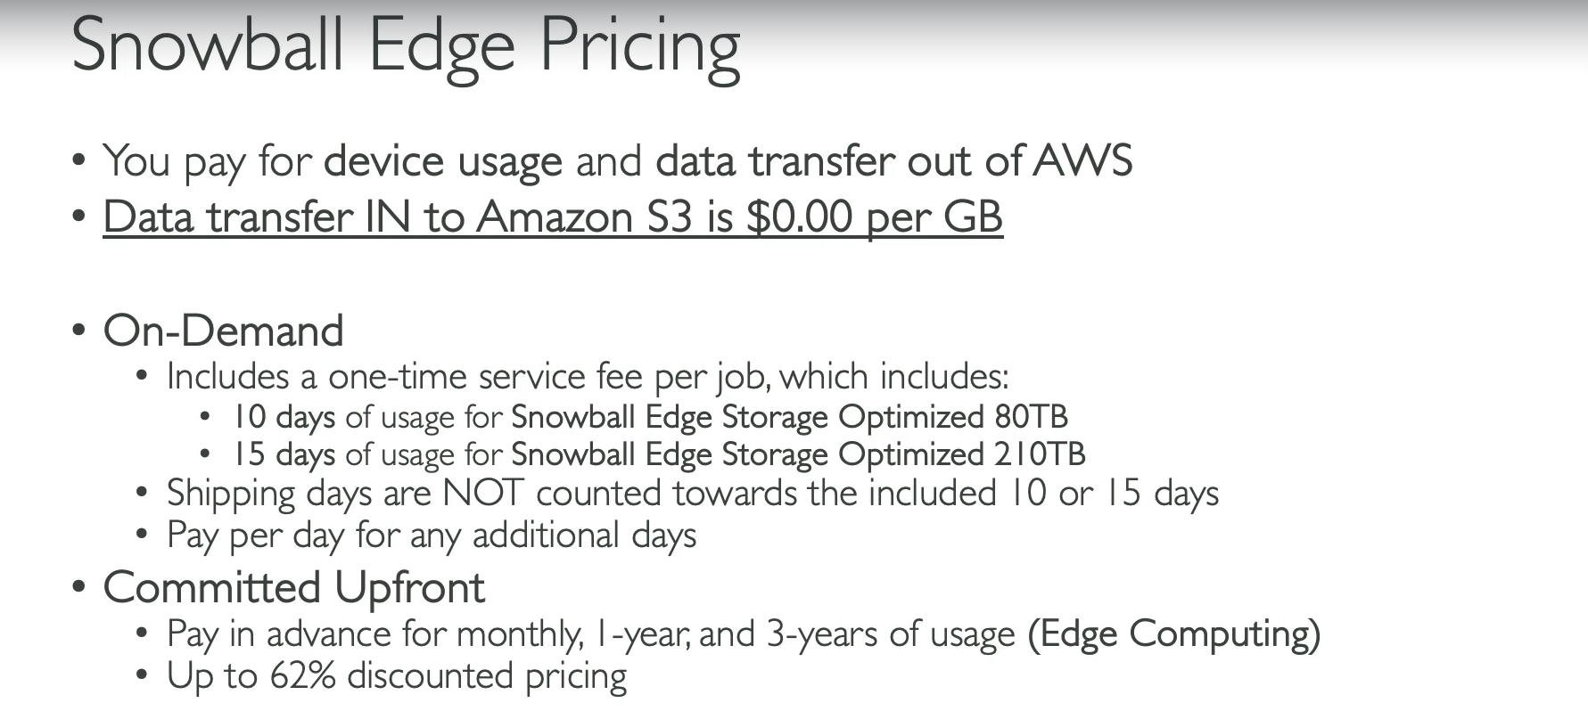

**Data Transfer Costs**

* **Data In:** Transferring data **from** a Snowball device **into** AWS (e.g., to an S3 bucket) is **free** ($0 per gigabyte).
* **Data Out:** Transferring data **out of** AWS **to** a Snowball device incurs standard S3 data transfer out fees, which are priced per gigabyte and vary by region.

**Device Usage Fees**

There are two main pricing models for the Snowball Edge device itself:

* **On-Demand:**
  + You pay a **one-time service fee per job**, which includes a set number of usage days.
  + For the **80 TB Storage Optimized** device, the fee includes **10 days** of on-site usage.
  + For the **210 TB Storage Optimized** device, the fee includes **15 days** of on-site usage.
  + The time the device is in transit (shipping to and from AWS) is **not** counted toward this usage limit.
  + After the initial free days, you will be charged a daily fee for each additional day you use the device.
* **Committed Upfront:**
  + You can commit to a long-term usage plan for **one or three years** for edge computing use cases.
  + This model offers a significant discount, up to **62% lower** than on-demand pricing.
  + It provides a flat, predictable monthly or annual fee, and you avoid the per-job and per-day fees during the commitment period.

1. **Storage Gateway Overview:**

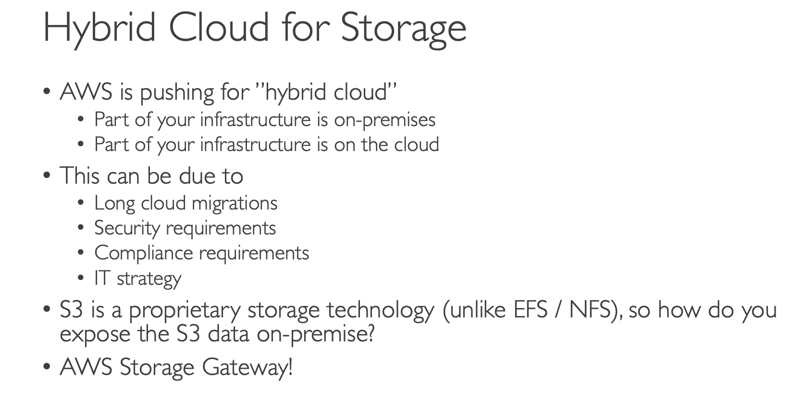

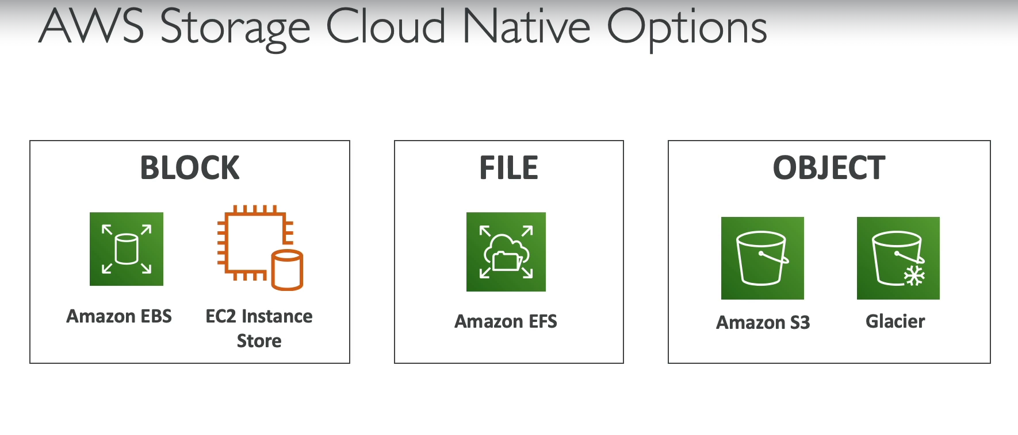

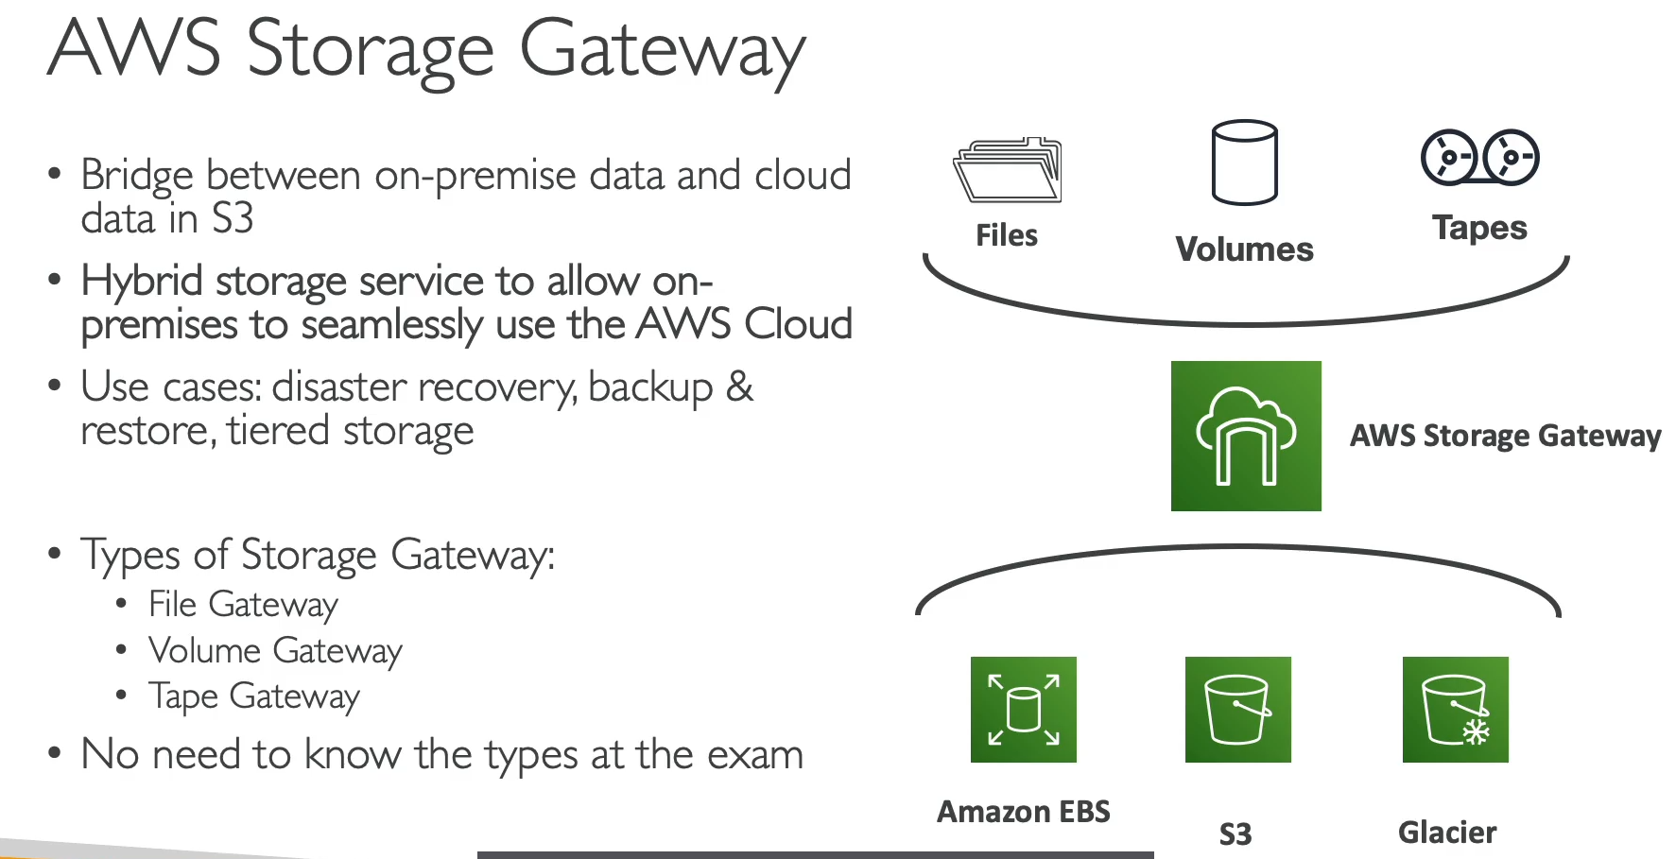

AWS Storage Gateway is a hybrid cloud storage service that connects your on-premises IT infrastructure with cloud storage on AWS. It allows on-premises applications to seamlessly use AWS cloud services like S3 and Glacier, without you having to re-engineer your applications.

**How It Works**

* **Bridge to the Cloud:** Storage Gateway acts as a bridge, providing on-premises applications with standard file, volume, or tape interfaces while storing the data durably in AWS cloud storage.
* **Virtual Appliance:** It is deployed on-premises as a virtual machine (VM) that you run on your existing virtualization platform (e.g., VMware, Hyper-V).
* **Underlying AWS Services:** Behind the scenes, the Storage Gateway service uses different AWS storage services to manage your data, including Amazon S3, S3 Glacier, and Amazon EBS, depending on the type of gateway used.

**Types of Gateways**

There are three main types of Storage Gateway, each designed for a specific use case:

* **File Gateway:** Provides file-based access (NFS and SMB protocols) to objects stored in Amazon S3. It's used for storing files and backing up on-premises data to S3.
* **Volume Gateway:** Provides block storage to on-premises applications using iSCSI. It can be configured in two modes:
  + **Cached Volumes:** Stores all data in S3 but caches frequently accessed data locally for low-latency access.
  + **Stored Volumes:** Keeps the entire dataset on-premises while asynchronously backing it up to S3 as EBS snapshots.
* **Tape Gateway:** A virtual tape library (VTL) that presents a virtual media changer and tape drives to your backup software. It's used to replace physical tape libraries, storing virtual tapes in S3 and archiving them to S3 Glacier for long-term retention.

1. **S3 Summary:**



